***ABOUT BLUEJ***

***_________________________***

BlueJ is a development environment that allows you to develop Java programs quickly and easily. It runs with the help of JDK (Java Development Kit).BlueJ supports java-programming language.Its main features are that it is:

* Simple-BlueJ has a deliberately smaller and simpler interface than professional environments like NetBeans or Eclipse. This allows beginners to get started more quickly, and without being overwhelmed.
* Designed for teaching-BlueJ is deliberately designed with good pedagogy in mind. There is a popular textbook designed for teaching introductory university/college courses with BlueJ, and a site full of teaching resources.
* Interactive-BlueJ allows you to interact with objects. You can inspect their value, call methods on them, and pass them as parameters and more. You can also directly invoke Java expressions without compiling.
* Portable- BlueJ runs on Windows, Mac OS X, Linux and other platforms which run Java. It can also run without installation from a USB stick.
* Mature- BlueJ is over fifteen years old, but continues to be updated and supported by a full-time team. We aim to respond to all technical support requests within one working day.
* Innovative BlueJ has several features not seen before in other IDEs. Its object bench, code pad, and scope colouring were all original BlueJ features.

JAVA is a programming language, developed by Sun Microsystems and invented by James Gosling, and first released in 1995 .Its hypothetical name was Oak.

OOP Characteristics:

* Objects.
* Classes.
* Data Abstraction.
* Encapsulation.
* Inheritance.
* Polymorphism.
* Dynamic Binding.

Java array is an object which contains elements of a similar data type. It is a data structure where we store similar elements. We can store only a fixed set of elements in a Java array. Array in java is index-based, the first element of the array is stored at the 0 index.

String is a sequence of characters but it's not a primitive type. When we create a string in java, it actually creates an object of type String. String is immutable object which means that it cannot be changed once it is created. String is the only class where operator overloading is supported in java.

The purpose of constructor is to initialize the object of a class while the purpose of a method is to perform a task by executing java code. Constructors cannot be abstract, final, static and synchronised while methods can be. Constructors do not have return types while methods do have.

Thus, was designed for flexibility, allowing developers to write code that would run on any machine, regardless of architecture or platform.

***INTRODUCTION***

***_________________________***

This is to meet the internal Assessment requirements of ICSE 2018-2019 Computer Applications paper. Apart from this, it is a great learning Experience too.

This project is a Java Application which enables user to generate a Railway ticket just by sitting at their homes. It also has a feature of Online Payment .

I choose this topic because this gives a good acquaintance with the pattern and the standard of the programming questions in the Board Exam. Some Aspects covered in this project are:

**» Menu Driven Program**

**» If-Else Statements**

**» Processing Strings**

**» Defining and calling Functions**

**» Arrays**

Apart from just theoretical scripting of a program, this project actually coerses us to edit, compile, debug and run our Application. Many Syntactical and practical program issues are implicitly understood while accomplishing the assignment.

***NEED OF THIS SYSTEM IN CURRENT TIME***

***_________________________***

IRCTC has changed the face of Indian railways ticketing system. You can book the rail ticket at IRCTC website from your PC, mobile phone and tablet. It’s also provides the SMS facility to check PNR status and live train running status.

Before the Invention of IRCTC, passengers were need to stand in long que to book the ticket. Their precious time was wasted. But through IRCTC, they can book the tickets sitting at their homes within few minutes. This saves a lot their time.

Further, online payment has made their job a lot easier. It is safe, speedy and easy way to transfer the money.

Thus, in today’s world, IRCTC has been a boon to Indian Railways.

***SYNOPSIS***

***_________________________***

Railway is a very important driver of tourism in any country and even more so one as large as India with weak road & hotel infrastructure. Being the tourism arm of Indian Railways, IRCTC makes an important contribution to overall growth of tourism in the country.

The flow of my program is:

Screen 1: Loading…

Screen 2: Introduction and information about IRCTC.

Screen 3: Main Menu.

Screen 4: Agreement of the Instructions.

Screen 5: Taking the date of journey.

Screen 6: Taking the Starting Point and Destination.

Screen 7: Selection of Train and Coach Type.

Screen 8: Taking of the Personal Details of the Passenger.

Screen 9: Asking for Food and its Quantity.

Screen 10: Asking to answer question to get 10% Discount.

Screen 11: The Bill.

Screen 12: Taking the payment through Net Banking or Credit card.

Screen 13: Exit.

At every Screen, Option to go to the previous Screen is given.

***CONCEPT IMPLEMENTED***

***_________________________***

# *Control flow statements*

Control flow statements, break up the flow of execution by employing decision making, looping, and branching, enabling the program to conditionally execute particular blocks of code.

 Concepts implemented in our project is : The decision-making statements (if, if -else, switch), the looping statements (for, while, do-while), and the branching statements (break, continue, return) supported by the Java programming language.

## The if Statement

The if-else statement is the most basic of all the control flow statements. It tells your program to execute a certain section of code only if a particular test evaluates to true.

## The if -else Statement

The if -else statement provides a secondary path of execution when an "if" clause evaluates to false. You could use an if -else statement

# The switch Statement

Unlike if and if -else statements, the switch statement can have a number of possible execution paths. A switch works with the byte, short, char, and int primitive data types.

The break statements are necessary because without them, statements in switch blocks fall through: All statements after the matching case label are executed in sequence, regardless of the expression of subsequent case labels, until a break statement is encountered.

# The for Statement

The for statement provides a compact way to iterate over a range of values. Programmers often refer to it as the "for loop" because of the way in which it repeatedly loops until a particular condition is satisfied. The general form of the for statement can be expressed as follows:

for (initialization; termination ; increment)

{

// statement(s)

}

When using this version of the for statement, keep in mind that:

* The initialization expression initializes the loop; it's executed once, as the loop begins.
* When the termination expression evaluates to false, the loop terminates.
* The increment expression is invoked after each iteration through the loop; it is perfectly acceptable for this expression to increment or decrement a value.

The while and do-while Statements

The while statement continually executes a block of statements while a particular condition is true. Its syntax can be expressed as:

while (expression)

{

statement(s)

}

The while statement evaluates expression, which must return a boolean value. If the expression evaluates to true, the while statement executes the statement(s) in the while block. The while statement continues testing the expression and executing its block until the expression evaluates to false

Do While :

The Java programming language also provides a do-while statement, which can be expressed as follows:

do

{

statement(s)

}

while (expression);

The difference between do-while and while is that do-while evaluates its expression at the bottom of the loop instead of the top. Therefore, the statements within the do block are always executed at least once,

## Strings

Strings, which are widely used in Java programming, are a sequence of characters. In the Java programming language, strings are objects. The String class is used to create and manipulate strings

The String class has a number of methods for examining the contents of strings, finding characters or substrings within a string, changing case, and other tasks.

**Arrays**

An array is a container object that holds a fixed number of values of a single type. The length of an array is established when the array is created. After creation, its length is fixed.

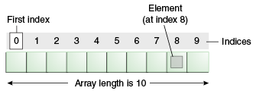

An array of 10 elements.

Each item in an array is called an element, and each element is accessed by its numerical index. As shown in the preceding illustration, numbering begins with 0. The 9th element, for example, would therefore be accessed at index 8.

# Classes and Objects

A class declaration names the class and encloses the class body between braces. The class name can be preceded by modifiers. The class body contains fields, methods, and constructors for the class. A class uses fields to contain state information and uses methods to implement behavior. Constructors that initialize a new instance of a class use the name of the class and look like methods without a return type.

The control access to classes and members in the same way: by using an access modifier such as public in their declaration.

Specify a class variable or a class method by using the static keyword in the member's declaration, A member that is not declared as static is implicitly an instance member. Class variables are shared by all instances of a class and can be accessed through the class name as well as an instance reference. Instances of a class get their own copy of each instance variable, which must be accessed through an instance reference.

# Defining Methods

The only required elements of a method declaration are the method's return type, name, a pair of parentheses, (), and a body between braces, {}.

More generally, method declarations have six components, in order:

1. Modifiers—such as public, private, and others you will learn about later.
2. The return type—the data type of the value returned by the method, or void if the method does not return a value.
3. The method name—the rules for field names apply to method names as well, but the convention is a little different.
4. The parameter list in parenthesis—a comma-delimited list of input parameters, preceded by their data types, enclosed by parentheses, (). If there are no parameters, you must use empty parentheses.
5. An exception list—to be discussed later.

The method body, enclosed between braces—the method's code, including the declaration of local variables, goes here.

***MY PROJECT CODE***

***__________________________***

***Class 1- Project***

import java.io.*;

import java.util.*;

import java.util.Calendar;

public class project

{

static int ch; static char p;static int y;

static int m; static int d2;static String f;

static Scanner sc=new Scanner(System.in);

static Scanner sc1=new Scanner(System.in);

public static void main(String args[])throws Exception

{

int i;

for(int j=1;j<=3;j++)

{

System.out.println();

System.out.println();

System.out.println();

System.out.println();

System.out.println();

System.out.println();

System.out.println();

System.out.println();

System.out.println();

System.out.println();

System.out.println();

System.out.println();

System.out.println();

System.out.println();

System.out.print(" ");

System.out.print("LOADING");

for(i=1;i<=5;i++)

{

Thread.sleep(500);

if(i==5)

System.out.print("\f");

else

System.out.print(".");

}

}

welcome();

intro();

}

public static void welcome()

{

PrintWriter a=new PrintWriter(System.out,true);

String h="ABOUT US.....";

a.println("\f-----------------------------------------------------------------------------------------------------------------------------------");

a.println(" # # ###### # #### #### # # ######");

a.println(" # # # # # # # ## ## #");

a.println(" # # ##### # # # # # ## # #####");

a.println(" # ## # # # # # # # # #");

a.println(" ## ## # # # # # # # #");

a.println(" # # ###### ###### #### #### # # ######");

a.println("-----------------------------------------------------------------------------------------------------------------------------------");

a.println(" INDIAN RAILWAYS CATERING AND TOURISM CORPORATION");

a.println("-----------------------------------------------------------------------------------------------------------------------------------");

a.println();

for(int i=0;i<h.length();i++)

{

for(int j=0;j<=100000000;j++)

{

}

System.out.print(h.charAt(i));

}

a.println();

a.println("The Ministry of Railways has set up the IRCTC (Indian Railways Catering and Tourism Corporation) for transferring all responsibility");

a.println("of tourism and catering to our new corporation. This has been done to ensure professionalism and upgradation of service through private"); ;

a.println("-public collaborations.Tourism via railways will be the source of high growth in our sector by coordinating with other agencies such as");

a.println("tour operators,hotels, travel agents etc. On the plate is a dynamic strategy of marketing in collaboration with private and public");

a.println("agencies such as hoteliers, tour operators, transporting agencies, travel agents and state agencies.Indian Railways has humungous");

a.println("potential to ICRTC as it carries along 13 million passengers daily. The mission of IRCTC is to enhance services of customers in");

a.println("railway hospitality,catering, travel and tourism with best practices of the industry.");

a.println();

a.println();

a.println();

a.println();

a.println();

}

public static boolean check(int a,int b)

{

if(a>=1 && a<=b)

{

return true;

}

else

{

System.out.println("Invalid choice");

System.out.println("Enter any key to try again");

sc1.nextLine();

return false;

}

}

public static boolean check2(char n)

{

if(n=='#'||n=='$')

{

return true;

}

else

{

System.out.println("Invalid choice");

System.out.println("Enter any key to try again");

sc1.nextLine();

return false;

}

}

public static void intro()

{

while(true)

{

String s="ENTER 1 TO PROCEED TO MAIN MENU....";

for(int i=0;i<s.length();i++)

{

for(int j=0;j<=100000000;j++)

{

}

System.out.print(s.charAt(i));

}

System.out.println();

ch=sc.nextInt();

if(check(ch,1)==true)

{

break;

}

}

System.out.println("\f");

run();

}

public static void run()

{

System.out.println("\f~~~~~~~~~~~~~~~~~~~~~~~~~~~~~~~~~~~~~~~~~~~~~~~~~~~~~~~~~~~~~~~~~~~~~~~~~~~~~~~~~~~~~~~~~~~~~~~~~~~~~~~~~~~~~~~~~~~~~~~~~~~~~~~~~~~");

System.out.println(" :::: :::: ::: ::::::::::: :::: ::: :::: :::: :::::::::: :::: ::: ::: :::");

System.out.println(" +:+:+: :+:+:+ :+: :+: :+: :+:+: :+: +:+:+: :+:+:+ :+: :+:+: :+: :+: :+:");

System.out.println(" +:+ +:+:+ +:+ +:+ +:+ +:+ :+:+:+ +:+ +:+ +:+:+ +:+ +:+ :+:+:+ +:+ +:+ +:+");

System.out.println(" +#+ +:+ +#+ +#++:++#++: +#+ +#+ +:+ +#+ +#+ +:+ +#+ +#++:++# +#+ +:+ +#+ +#+ +:+");

System.out.println(" +#+ +#+ +#+ +#+ +#+ +#+ +#+#+# +#+ +#+ +#+ +#+ +#+#+# +#+ +#+");

System.out.println(" #+# #+# #+# #+# #+# #+# #+#+# #+# #+# #+# #+# #+#+# #+# #+#");

System.out.println(" ### ### ### ### ########### ### #### ### ### ########## ### #### ########");

while(true)

{

System.out.println("~~~~~~~~~~~~~~~~~~~~~~~~~~~~~~~~~~~~~~~~~~~~~~~~~~~~~~~~~~~~~~~~~~~~~~~~~~~~~~~~~~~~~~~~~~~~~~~~~~~~~~~~~~~~~~~~~~~~~~~~~~~~~~~~~~~");

System.out.println("1.BOOK THE TICKET");

System.out.println("2.CANCEL THE TICKET");

System.out.println("3.BACK");

System.out.println("4.EXIT");

System.out.println("-----------------------------------------------------------------------------------------------------------------------------------");

System.out.println("Enter your choice.....");

ch=sc.nextInt();

if(check(ch,4)==true)

{

break;

}

}

if(ch==1)

{

book();

}

else if(ch==2)

{

cancel();

}

else if(ch==3)

{

welcome();

intro();

}

else if(ch==4)

{

System.exit(0);

}

}

public static void cancel()

{

System.out.println("\f");

System.out.print("********************************************");

String q="WELCOME TO INDIAN RAILWAYS CANCELLATION COUNTER";

for(int i=0;i<q.length();i++)

{

for(int j=0;j<=100000000;j++)

{

}

System.out.print(q.charAt(i));

}

System.out.print("****************************************");

System.out.println();

System.out.println("***********************************************************************************************************************************");

System.out.println();

System.out.println("Enter your Passenger Number");

ch=sc.nextInt();

if(ch==154)

{

System.out.println("Your ticket has been Successfully Cancelled");

System.out.println("As per the rules 50% of the fare will be refunded to you Shortly");

project2 ob=new project2();

ob.thanks();

}

else

{

System.out.println("Wrong Passenger Number");

System.out.println("Sorry....you will have to return to Main menu Again");

for(int i=0;i<=1000000000;i++)

{

}

for(int j=0;j<=1000000000;j++)

{

}

for(int j=0;j<=1000000000;j++)

{

}

for(int j=0;j<=1000000000;j++)

{

}

for(int j=0;j<=100000000;j++)

{

}

for(int j=0;j<=1000000000;j++)

{

}

run();

}

}

public static void book()

{

System.out.println("\f");

System.out.print("********************************************");

String q="WELCOME TO INDIAN RAILWAYS BOOKING COUNTER";

for(int i=0;i<q.length();i++)

{

for(int j=0;j<=100000000;j++)

{

}

System.out.print(q.charAt(i));

}

System.out.print("*********************************************");

System.out.println();

System.out.println("***********************************************************************************************************************************");

System.out.println();

System.out.println();

System.out.println();

System.out.println("-----------------------------------------------------------------------------------------------------------------------------------");

System.out.println("There are few instructions which are needed to be follow:-");

System.out.println("1.Tickets can be cancelled only for a valid reason");

System.out.println("2.Only 50% of fare will be refunded in case of cancellation");

System.out.println("3.Tickets can be only booked within four(4) months of journey");

System.out.println("4.Tickets are only available for december 2018 and whole 2019");

System.out.println("5..We do not take any personal responsibility in case of an accident");

System.out.println("-----------------------------------------------------------------------------------------------------------------------------------");

System.out.println();

while(true)

{

System.out.println("ENTER 1 IF YOU AGREE ALL THE INSTRUCTIONS ");

System.out.println("ENTER 2 IF YOU WANT DO NOT AGREE ALL THE INSTRUCTIONS");

System.out.println("In case of non-agreement you cant book the ticket,sorry........you have to proceed to menu menu again");

ch=sc.nextInt();

if(check(ch,2)==true)

{

break;

}

}

if(ch==2)

{

run();

}

if(ch==1)

{

book1();

}

}

public static void book1()

{

System.out.println();

System.out.println();

while(true)

{

System.out.println("Enter # to proceed....");

System.out.println("Enter $ to go back ");

p=sc.next().charAt(0);

if(check2(p)==true)

{

break;

}

}

if(p=='#')

{

System.out.println("\f");

year();

}

else if(p=='$')

{

run();

}

}

public static boolean check3(int y2)

{

if(y2==2018||y2==2019)

{

return true;

}

else

{

System.out.println("Invalid choice of year.....Ticket is only booked within four months of journey");

System.out.println("Enter any key to try again");

sc1.nextLine();

return false;

}

}

public static boolean check4(int t,int g)

{

Calendar c=Calendar.getInstance();

int z=c.get(Calendar.MONTH)+1;

if(t==1)

{

if((z-t==10||z-t==11||z-t==0)&& g==2019)

{

return true;

}

else

{

if(g==2018)

System.out.println("Invalid choice of month.....Tickets are avilable only for december of 2018 and whole of 2019");

else

System.out.println("Invalid choice of month......Tickets are available only within four months of journey");

System.out.println("Enter any key to try again");

sc1.nextLine();

return false;

}

}

else if(t==2)

{

if((z-t==10||z-t==11||z-t==0)&& g==2019)

{

return true;

}

else

{

if(g==2018)

System.out.println("Invalid choice of month.....Tickets are avilable only for december of 2018 and whole of 2019");

else

System.out.println("Invalid choice of month......Tickets are available only within four months of journey");

System.out.println("Enter any key to try again");

sc1.nextLine();

return false;

}

}

else if(t==3)

{

if((z-t==8||z-t==9||z-t==-2||z-t==-1||z-t==0)&&g==2019)

{

return true;

}

else

{

if(g==2018)

System.out.println("Invalid choice of month.....Tickets are avilable only for december of 2018 and whole of 2019");

else

System.out.println("Invalid choice of month......Tickets are available only within four months of journey");

System.out.println("Enter any key to try again");

sc1.nextLine();

return false;

}

}

else if(t==4)

{

if((z-t==8||z-t==-1||z-t==-2||z-t==-3||z-t==0)&&g==2019)

{

return true;

}

else

{

if(g==2018)

System.out.println("Invalid choice of month.....Tickets are avilable only for december of 2018 and whole of 2019");

else

System.out.println("Invalid choice of month......Tickets are available only within four months of journey");

System.out.println("Enter any key to try again");

sc1.nextLine();

return false;

}

}

else if(t==5)

{

if((z-t==-4||z-t==-3||z-t==-2||z-t==-1||z-t==0)&&g==2019)

{

return true;

}

else

{

if(g==2018)

System.out.println("Invalid choice of month.....Tickets are avilable only for december of 2018 and whole of 2019");

else

System.out.println("Invalid choice of month......Tickets are available only within four months of journey");

System.out.println("Enter any key to try again");

sc1.nextLine();

return false;

}

}

else if(t==6)

{

if((z-t==-4||z-t==-3||z-t==-2||z-t==-1||z-t==0)&&g==2019)

{

return true;

}

else

{

if(g==2018)

System.out.println("Invalid choice of month.....Tickets are avilable only for december of 2018 and whole of 2019");

else

System.out.println("Invalid choice of month......Tickets are available only within four months of journey");

System.out.println("Enter any key to try again");

sc1.nextLine();

return false;

}

}

else if(t==7)

{

if((z-t==-4||z-t==-3||z-t==-2||z-t==-1||z-t==0)&&g==2019)

{

return true;

}

else

{

if(g==2018)

System.out.println("Invalid choice of month.....Tickets are avilable only for december of 2018 and whole of 2019");

else

System.out.println("Invalid choice of month......Tickets are available only within four months of journey");

System.out.println("Enter any key to try again");

sc1.nextLine();

return false;

}

}

else if(t==8)

{

if((z-t==-4||z-t==-3||z-t==-2||z-t==-1||z-t==0)&&g==2018)

{

return true;

}

else

{

if(g==2018)

System.out.println("Invalid choice of month.....Tickets are avilable only for december of 2018 and whole of 2019");

else

System.out.println("Invalid choice of month......Tickets are available only within four months of journey");

System.out.println("Enter any key to try again");

sc1.nextLine();

return false;

}

}

else if(t==9)

{

if((z-t==-4||z-t==-3||z-t==-2||z-t==-1||z-t==0)&&g==2018)

{

return true;

}

else

{

if(g==2018)

System.out.println("Invalid choice of month.....Tickets are avilable only for december of 2018 and whole of 2019");

else

System.out.println("Invalid choice of month......Tickets are available only within four months of journey");

System.out.println("Enter any key to try again");

sc1.nextLine();

return false;

}

}

else if(t==10)

{

if((z-t==-4||z-t==-3||z-t==-2||z-t==-1||z-t==0)&& g==2019)

{

return true;

}

else

{

if(g==2018)

System.out.println("Invalid choice of month.....Tickets are avilable only for december of 2018 and whole of 2019");

else

System.out.println("Invalid choice of month......Tickets are available only within four months of journey");

System.out.println("Enter any key to try again");

sc1.nextLine();

return false;

}

}

else if(t==11)

{

if((z-t==-4||z-t==-3||z-t==-2||z-t==-1||z-t==0)&& g==2019)

{

return true;

}

else

{

if(g==2018)

System.out.println("Invalid choice of month.....Tickets are avilable only for december of 2018 and whole of 2019");

else

System.out.println("Invalid choice of month......Tickets are available only within four months of journey");

System.out.println("Enter any key to try again");

sc1.nextLine();

return false;

}

}

else if(t==12&&g==2018)

{

if(z-t==-1||z-t==0)

{

return true;

}

else

{

System.out.println("Invalid choice of month.....Ticket is only booked within four months of journey");

System.out.println("Enter any key to try again");

sc1.nextLine();

return false;

}

}

else if(t==12&&g==2019)

{

if(z-t==-1||z-t==-2||z-t==-3||z-t==-4||z-t==0)

{

return true;

}

else

{

System.out.println("Invalid choice of month.....Ticket is only booked within four months of journey");

System.out.println("Enter any key to try again");

sc1.nextLine();

return false;

}

}

else

{

System.out.println("Invalid choice of month.....");

System.out.println("Enter any key to try again");

sc1.nextLine();

return false;

}

}

public static boolean check5(int d3,int x)

{

Calendar c=Calendar.getInstance();

int r=c.get(Calendar.DATE);

int z=c.get(Calendar.MONTH)+1;

if(x==1||x==3||x==5||x==7||x==8||x==10||x==12)

{

if(z-x==0 &&(d3>r&&d3<=31))

return true;

if((d3<=31&&z-x!=0))

return true;

else

{

System.out.println("Invalid choice of date...");

System.out.println("Enter any key to try again");

sc1.nextLine();

return false;

}

}

if(x==2)

{

if(z-x==0 &&(d3>r&&d3<=28))

return true;

else if((d3<=28&&z-x!=0))

return true;

else

{

System.out.println("Invalid choice of date...");

System.out.println("Enter any key to try again");

sc1.nextLine();

return false;

}

}

if(x==4||x==6||x==9||x==11)

{

if(z-x==0 &&(d3>r&&d3<=30))

return true;

else if((d3<=30&&z-x!=0))

return true;

else

{

System.out.println("Invalid choice of date...");

System.out.println("Enter any key to try again");

sc1.nextLine();

return false;

}

}

else

{

System.out.println("Invalid choice of date...");

System.out.println("Enter any key to try again");

sc1.nextLine();

return false;

}

}

public static boolean check6(String yn)

{

if(yn.equalsIgnoreCase("yes")||yn.equalsIgnoreCase("no"))

return true;

else

{

System.out.println("Invalid choice");

System.out.println("Enter any key to try again");

sc1.nextLine();

return false;

}

}

public static boolean check7(char o)

{

if(o=='@'||o=='*')

return true;

else

{

System.out.println("Invalid choice");

System.out.println("Enter any key to try again");

sc1.nextLine();

return false;

}

}

public static void year()

{

System.out.println("\f@@@@@@@@@@@@@@@@@@@@@@@@@@@@@@@@@@@@@@@@@@@@@@@@@@@@@@@@@@@@@@@@@@@@@@@@@@@@@@@@@@@@@@@@@@@@@@@@@@@@@@@@@@@@@@@@@@@@@@@@@@@@@@@@@@@");

System.out.println();

while(true)

{

System.out.println("Enter the year in which you have to travel");

y=sc.nextInt();

if(check3(y)==true)

{

break;

}

}

System.out.println("Ok..."+" "+y+ " "+"is a valid year");

System.out.println();

month();

}

public static void month()

{

while(true)

{

System.out.println("Enter the month number of"+ " "+ y + " " +" in which you want to travel");

m=sc.nextInt();

if(check4(m,y)==true)

{

break;

}

}

System.out.println("Ok..."+" "+m+ " "+"is a valid month");

System.out.println();

day();

}

public static void day()

{

while(true)

{

System.out.println("Enter the day of month"+ " "+ m + " " +" in which you want to travel");

d2=sc.nextInt();

if(check5(d2,m)==true)

{

break;

}

}

System.out.println("Ok..."+" "+d2+ " "+"is a valid day");

System.out.println();

System.out.println("SO YOUR DATE OF DEPARTURE IS" +" "+d2+"/"+m+"/"+y);

while(true)

{

System.out.println("Is the above date is final");

System.out.println("Enter yes or no");

f=sc.next();

if(check6(f)==true)

{

break;

}

}

if(f.equalsIgnoreCase("yes"))

{

while(true)

{

System.out.println("ENTER @ TO PROCEED");

System.out.println("ENTER * TO GO BACK");

p=sc.next().charAt(0);

if(check7(p)==true)

{

break;

}

}

if(p=='@')

{

project2 ob=new project2();

ob.train();

}

else if(p=='*')

{

book();

}

}

else if(f.equalsIgnoreCase("no"))

{

year();

}

}

public static void transfer()

{

System.out.println("Date of journey:- "+d2+"/"+m+"/"+y);

}

}

***Class 2-Project2***

import java.util.Date;

import java.util.*;

class project2

{

static double tf;static double fl;static String phone;static String h1;static int ch;static String dest;

static String arr;static int tr;static String h;static char p;static int ch1;static int passengers; static String x1;

static String coach2[]={"AC CLASS","SLEEPER CLASS"};static int foodquantity;static int fare;

static Scanner sc=new Scanner(System.in);static String t2;static int cnf=0;static int coach;

static Scanner sc1=new Scanner(System.in);static String name[]=new String[6];

static String td;static String ta;static String gender[]=new String[6];static int age2[]=new int[6];

static project ob=new project();static int food;static int offer;static int ans;

static String station[]={"BORIVALI","HOWRAH","BANGALORE","DELHI CENTRAL","CHENNAI CENTRAL","PUNE JUNCTION",

"AHMEDABAD JUNCTION","VACO DA GAMA","AMRITSAR JUNCTION","KATRA","CHANDIGARH","VIJAYWADA JUNCTION","BHOPAL","JAIPUR",

"NAHARLAGUN","SILIGURI","KATHGODAM","DIMAPUR","SHIMLA","GORAKHPUR JUNCTION","KHARAGPUR","KOLLAM","KOTA",

"RATLAM","SURAT","GUWAHATI","MENDIPATHAR","BAIRABI","AGARTALA",};

static String train[]={"Rajdhani","Shatabdi","Lok shakti","Karanavati","Udyan Express","Garib rath","Indrayani",

"Saurashtra Mail","Nizamuddin","Swaraj Express"};

static int cost[]={2000,1500,550,450,1000,400,600,540,1400,1500};

static int cost2[]={1500,1200,300,350,575,200,400,400,900,915};

static String time1[]={"6:30pm","7:30pm","12:30pm","4:00pm","8:30am","7:40pm","7:30am","11:15pm","2:00am","9:15pm"};

static String time2[]={"8:00am","3:00am","1:00am","8:10am","8:00am","10:00am","4:00pm","10:10am","4:00pm","5:25pm"};

public static void train()

{

System.out.println("\f");

System.out.print("<<<<<<<<<<<<<<<<<<<<<<<<<<<<<<<<<<<<<<<<<<<<<<<<<<<<<<");

System.out.print("Selection of station");

System.out.print(">>>>>>>>>>>>>>>>>>>>>>>>>>>>>>>>>>>>>>>>>>>>>>>>>>>>>>>>>");

System.out.println();

System.out.println();

System.out.println("Choose the starting point of your journey from the above list of stations:-");

System.out.println("1.BORIVALI\t\t 14.JAIPUR\t\t 27.MENDIPATHAR");

System.out.println("2.HOWRAH\t\t 15.NAHARLAGUN\t\t 28.BAIRABI");

System.out.println("3.BANGALORE\t\t 16.SILIGURI\t\t 29.AGARTALA");

System.out.println("4.DELHI CENTRAL\t\t 17.KATHGODAM");

System.out.println("5.CHENNAI CENTRAL\t 18.DIMAPUR");

System.out.println("6.PUNE JUNCTION\t\t 19.SHIMLA");

System.out.println("7.AHMEDABAD JUNCTION\t 20.GORAKHPUR JUNCTION ");

System.out.println("8.VASDO DA GAMA\t\t 21.KHARAGPUR");

System.out.println("9.AMRITSAR JUNCTION\t 22.KOLLAM");

System.out.println("10.KATRA\t\t 23.KOTA");

System.out.println("11.CHANDIGARH\t\t 24.RATLAM");

System.out.println("12.VIJAYWADA JUNCTION\t 25.SURAT");

System.out.println("13.BHOPAL\t\t 26.GUWAHATI");

System.out.println();

while(true)

{

System.out.println("Enter your choice(in number)");

ch=sc.nextInt();

if(ob.check(ch,29)==true)

{

break;

}

}

arr=station[ch-1];

verify2();

}

public static void verify2()

{

System.out.println("So,your starting point is"+" "+arr);

while(true)

{

System.out.println("Is it is confirm...Enter yes or no");

h=sc.next();

if(ob.check6(h)==true)

{

break;

}

}

if(h.equalsIgnoreCase("no"))

{

train();

}

else if(h.equalsIgnoreCase("yes"))

{

train2();

}

}

public static void train2()

{

System.out.println();

System.out.println();

System.out.println("Choose the destination of your journey from the above list of stations:-");

System.out.println("1.BORIVALI\t\t 14.JAIPUR\t\t 27.MENDIPATHAR");

System.out.println("2.HOWRAH\t\t 15.NAHARLAGUN\t\t 28.BAIRABI");

System.out.println("3.BANGALORE\t\t 16.SILIGURI\t\t 29.AGARTALA");

System.out.println("4.DELHI CENTRAL\t\t 17.KATHGODAM");

System.out.println("5.CHENNAI CENTRAL\t 18.DIMAPUR");

System.out.println("6.PUNE JUNCTION\t\t 19.SHIMLA");

System.out.println("7.AHMEDABAD JUNCTION\t 20.GORAKHPUR JUNCTION ");

System.out.println("8.VASDO DA GAMA\t\t 21.KHARAGPUR");

System.out.println("9.AMRITSAR JUNCTION\t 22.KOLLAM");

System.out.println("10.KATRA\t\t 23.KOTA");

System.out.println("11.CHANDIGARH\t\t 24.RATLAM");

System.out.println("12.VIJAYWADA JUNCTION\t 25.SURAT");

System.out.println("13.BHOPAL\t\t 26.GUWAHATI");

System.out.println();

while(true)

{

System.out.println("Enter your choice(in number)");

ch1=sc.nextInt();

if(ob.check(ch1,29)==true && check9(ch1)==true)

{

break;

}

}

dest=station[ch1-1];

verify3();

}

public static boolean check9(int a)

{

if(ch1!=ch)

{

return true;

}

else

{

System.out.println("Starting point and destination cant be same");

System.out.println("Enter any key to try again");

sc1.nextLine();

return false;

}

}

public static boolean check8(String yn)

{

if((yn.equalsIgnoreCase("yes")||yn.equalsIgnoreCase("no")))

{

return true;

}

else

{

System.out.println("Invalid choice");

System.out.println("Enter any key to try again");

sc1.nextLine();

return false;

}

}

public static void verify3()

{

System.out.println("So..your destination is "+dest);

while(true)

{

System.out.println("Is it is confirm...Enter yes or no");

h=sc.next();

if(check8(h)==true)

{

break;

}

}

if(h.equalsIgnoreCase("yes"))

{

while(true)

{

System.out.println("ENTER @ TO PROCEED");

System.out.println("ENTER * TO GO BACK");

p=sc.next().charAt(0);

if(ob.check7(p)==true)

{

break;

}

}

if(p=='@')

{

traindetails();

}

else if(p=='*')

{

ob.year();

}

}

else if(h.equalsIgnoreCase("no"))

{

train2();

}

}

public static void traindetails()

{

System.out.println("\f");

System.out.println("Trains going from " +arr +" " +"to " +dest +" "+"are:-");

System.out.println("TRAIN NAME \t\t FARE(AC CLASS)\t\t FARE(SLEEPER CLASS) \t TIMING OF DEPARTURE \t TIMING OF ARRIVAL ");

System.out.println(" \t\t \t\t FROM STATRING POINT\t AT DESTINATION");

System.out.println();

System.out.println("1.Rajdhani \t\t Rs.2000\t\t Rs.1500 \t\t 6:30pm \t\t\t 8:00am");

System.out.println("2.Shatabdi \t\t Rs.1500\t\t Rs.1200 \t\t 7:30pm \t\t\t 3:00am");

System.out.println("3.Lok shakti\t\t Rs.550\t\t\t Rs.300 \t\t 12:30pm \t\t\t 1:00am");

System.out.println("4.Karanavati \t\t Rs.450\t\t\t Rs.350 \t\t 4:00pm \t\t\t 8:10am");

System.out.println("5.Udyan Express \t Rs.1000\t\t Rs.575 \t\t 8:30am \t\t\t 8:00am");

System.out.println("6.Garib rath \t\t Rs.400\t\t\t Rs.200 \t\t 7:40pm \t\t\t 10:00am");

System.out.println("7.Indrayani \t\t Rs.600\t\t\t Rs.400 \t\t 7:30am \t\t\t 4:00pm");

System.out.println("8.Saurashta Mail \t Rs.540\t\t\t Rs.400 \t\t 11:15pm \t\t\t 10:10am");

System.out.println("9.Nizamuddin \t\t Rs.1400\t\t Rs.900 \t\t 2:00am \t\t\t 4:00pm");

System.out.println("10.Swaraj Express \t Rs.1500\t\t Rs.915 \t\t 9:15pm \t\t\t 5:25pm");

while(true)

{

System.out.println();

System.out.println("Enter your choice(in number)");

tr=sc.nextInt();

if(ob.check(tr,10)==true)

{

break;

}

}

t2=train[tr-1];

td=time1[tr-1];

ta=time2[tr-1];

train3();

}

public static void train3()

{

System.out.println("So..the train name is "+t2);

while(true)

{

System.out.println("Is it final...Enter yes or no");

h=sc.next();

if(ob.check6(h)==true)

{

break;

}

}

if(h.equalsIgnoreCase("no"))

traindetails();

else if(h.equalsIgnoreCase("yes"))

classn();

}

public static void classn()

{

System.out.println();

System.out.println();

while(true)

{

System.out.println("Enter the type of coach from the below list(in number):-");

System.out.println("1.AC CLASS");

System.out.println("2.SLEEPER CLASS");

coach=sc.nextInt();

if(ob.check(coach,2)==true)

break;

}

System.out.println("Ok..valid choice");

x1=coach2[coach-1];

if(coach==1)

fare=cost[tr-1];

else if(coach==2)

fare=cost2[tr-1];

System.out.println();

System.out.println();

while(true)

{

System.out.println("ENTER @ TO PROCEED");

System.out.println("ENTER * TO GO BACK");

p=sc.next().charAt(0);

if(ob.check7(p)==true)

{

break;

}

}

if(p=='@')

details();

else if(p=='*')

train();

}

public static void details()

{

System.out.println("\f");

System.out.print("<<<<<<<<<<<<<<<<<<<<<<<<<<<<<<<<<<<<<<<<<<<<<<<<<<<<<<<<");

System.out.print("Passenger Details");

System.out.print(">>>>>>>>>>>>>>>>>>>>>>>>>>>>>>>>>>>>>>>>>>>>>>>>>>>>>>>>>>");

number();

}

public static void number()

{

System.out.println();

while(true)

{

System.out.println("Enter number of passengers who are travelling(Maximum limit is 6)");

passengers=sc.nextInt();

if(ob.check(passengers,6)==true)

break;

}

System.out.println("Ok..valid passengers");

name();

}

public static void name()

{

System.out.println();

int i;

for(i=0;i<passengers;i++)

{

System.out.println("Enter first name of " + (i+1) +" passenger");

name[i]=sc.next();

}

age();

}

public static void age()

{

System.out.println();

System.out.println();

int i;

for(i=0;i<passengers;i++)

{

while(true)

{

System.out.println("Enter age of " + (i+1) +" passenger");

age2[i]=sc.nextInt();

if(ob.check(age2[i],110)==true)

{

break;

}

}

}

gender();

}

public static boolean check10(String yn)

{

if(yn.equalsIgnoreCase("male")||yn.equalsIgnoreCase("female"))

{

return true;

}

else

{

System.out.println("Invalid choice of gender");

System.out.println("Enter any key to try again");

sc1.nextLine();

return false;

}

}

public static void gender()

{

System.out.println();

System.out.println();

int i;

for(i=0;i<passengers;i++)

{

while(true)

{

System.out.println("Enter gender of " + (i+1) +" passenger(male/female)");

gender[i]=sc.next();

if(check10(gender[i])==true)

break;

}

}

verify4();

}

public static void verify4()

{

System.out.println();

System.out.println();

System.out.println("So..are all tour details confirmed?");

while(true)

{

System.out.println("Enter yes or no");

h=sc.next();

if(check8(h)==true)

break;

}

if(h.equalsIgnoreCase("yes"))

proceed();

else if(h.equalsIgnoreCase("no"))

details();

}

public static void proceed()

{

System.out.println();

System.out.println();

while(true)

{

System.out.println("ENTER 1 TO PROCEED");

System.out.println("ENTER 2 TO GO BACK");

ch=sc.nextInt();

if(ob.check(ch,2)==true)

{

break;

}

}

if(ch==1)

food();

else if(ch==2)

traindetails();

}

public static void food()

{

System.out.println("\f");

System.out.print("<<<<<<<<<<<<<<<<<<<<<<<<<<<<<<<<<<<<<<<<<<<<<<<<<<<<<<<<<<");

System.out.print("FOOD OPTIONS"); System.out.print(">>>>>>>>>>>>>>>>>>>>>>>>>>>>>>>>>>>>>>>>>>>>>>>>>>>>>>>>>>>>>");

System.out.println();

System.out.println();

System.out.println("Do you want food in your journey");

while(true)

{

System.out.println("Enter yes or no");

h=sc.next();

if(check8(h)==true)

break;

}

if(h.equalsIgnoreCase("yes"))

menu();

else if(h.equalsIgnoreCase("no"))

again();

}

public static void again()

{

System.out.println("ARE YOU SURE?????");

while(true)

{

System.out.println("Enter yes or no");

h=sc.next();

if(check8(h)==true)

break;

}

if(h.equalsIgnoreCase("yes"))

proceed2();

else if(h.equalsIgnoreCase("no"))

food();

}

public static void menu()

{

System.out.println();

System.out.println();

System.out.println("~~~~~~~~~~~~~~~~~~~~~~~~~~~~~~~~~~~~~~~~~~~~~~~~~~~~~~~~~~~~~~~~~~~~~~~~~~~~~~~~~~~~~~~~~~~~~~~~~~~~~~~~~~~~~~~~~~~~~~~~~~~~~~~~~~~");

System.out.println(" FOOD ITEMS \t\t\t\t\t\t\t\t RATE \t\t\t CATEGORY");

System.out.println();

System.out.println("1.Chapatti,Rice,panner tikka masala,Bhindi masala,Dal fry,Rasgulla,Tea \t\t Rs.500 \t\t Veg(Jain)");

System.out.println("2.Chapatti,Rice,panner tikka masala,Bhindi masala,Dal fry,Rasgulla,Tea \t\t Rs.500 \t\t Veg(Non-Jain)");

System.out.println("3.Rice,omlet,chicken tandoori,Dal fry,Rasgulla,Tea \t\t\t\t Rs.500 \t\t Non-Veg");

System.out.println("4.Chapatti,Rice,Veg.Kolhapuri,Chana masala,Dal fry,Gulab Jamun,Tea \t\t Rs.500 \t\t Veg(Jain)");

System.out.println("5.Veg.Margarita pizza,pasta,tea \t\t\t\t\t\t Rs.500 \t\t Veg(Jain)");

System.out.println("6.Veg.Margarita pizza,pasta,tea \t\t\t\t\t\t Rs.500 \t\t Veg(Non-Jain)");

System.out.println();

while(true)

{

System.out.println("Enter your choice(in number)...You can select any 1 of the food option enlisted above");

food=sc.nextInt();

if(ob.check(food,6)==true)

break;

}

cnf=1;

verify5();

}

public static void verify5()

{

while(true)

{

System.out.println("Enter the total number of quantity of your selected food(maximum is 6)");

foodquantity=sc.nextInt();

if(ob.check(foodquantity,6)==true)

break;

}

System.out.println("So..your food option number is "+food +" "+"and quantity is "+foodquantity) ;

System.out.println("Is it confirmed");

while(true)

{

System.out.println("Enter 1 for yes and 2 for no");

ch=sc.nextInt();

if(ob.check(ch,2)==true)

break;

}

if(ch==1)

proceed2();

else if(ch==2)

menu();

}

public static void offer()

{

System.out.println("\f");

System.out.println();

System.out.println("We have a special offer for you:-");

System.out.println("We will ask you a question....If you answer it correctly,you will get 10% discount on ");

System.out.println("your fare and if you answer it wrong,no discount will be available");

while(true)

{

System.out.println();

System.out.println("Enter 1 if you accept it");

System.out.println("Enter 2 if you reject it");

offer=sc.nextInt();

if(ob.check(offer,2)==true)

break;

}

if(offer==1)

question();

else if(offer==2)

proceed3();

}

public static void proceed2()

{

System.out.println();

System.out.println();

while(true)

{

System.out.println("ENTER 1 TO PROCEED");

System.out.println("ENTER 2 TO GO BACK");

ch=sc.nextInt();

if(ob.check(ch,2)==true)

{

break;

}

}

if(ch==1)

offer();

else if(ch==2)

details();

}

public static void question()

{

System.out.println();

System.out.println();

System.out.println("THE QUESTION FOR YOU IS");

System.out.println("Who has won the IPL 2017?");

System.out.println("1.Rising Pune Supergiants \t\t 2.Sunrisers Hyderabad");

System.out.println("3.Mumbai Indians \t\t\t 4.Royal Challengers Bangalore");

System.out.println();

while(true)

{

System.out.println("Enter your answer");

ch=sc.nextInt();

if(ob.check(ch,4)==true)

break;

}

switch(ch)

{

case 1:

case 2:

case 4:

ans=0;

System.out.println("Oops..you have answered it wrong,the correct answer is Option 3,no disount");

proceed3();

break;

case 3:

ans=1;

System.out.println("Congratulations....you have answered it right,you will get 10% discount on your fare");

proceed3();

break;

}

}

public static void proceed3()

{

System.out.println();

System.out.println();

while(true)

{

System.out.println("ENTER 1 TO PROCEED TO PAY THE BILL");

ch=sc.nextInt();

if(ob.check(ch,1)==true)

break;

}

if(ch==1)

bill();

}

public static void bill()

{

System.out.println("\f-----------------------------------------------------------------------------------------------------------------------------------");

System.out.println(" ###### ### # # ");

System.out.println(" # # # # # ");

System.out.println(" # # # # # ");

System.out.println(" ###### # # # ");

System.out.println(" # # # # # ");

System.out.println(" # # # # # ");

System.out.println(" ###### ### ####### ####### ");

System.out.println("-------------------------------------------------------------------------------------------------------------------------------------");

System.out.println();

Date ob=new Date();

String s=ob.toString();

System.out.println("Booking Time and Date:- "+s);

main();

System.out.println("Starting point:- "+arr);

System.out.println("Destination:- "+dest);

System.out.println("Timing of Departure from "+arr+" :-"+td);

System.out.println("Timing of Arrival at "+dest+" :-"+ta);

System.out.println("Train Name:- "+ t2);

System.out.println("Coach Type:- "+x1);

if(x1.equals("SLEEPER CLASS"))

{

System.out.print("Coach Number:- S");

System.out.print((int)(Math.random()*10)+1);

}

else if(x1.equals("AC CLASS"))

{

System.out.print("Coach Number:- A");

System.out.print((int)(Math.random()*9)+1);

}

System.out.println();

System.out.println("Passenger Number:- 154");

System.out.println();

System.out.println("NAME OF PASSENGER \t\t\t\t AGE OF PASSENGER \t\t GENDER OF PASSENGER \t\tSEAT NO.");

System.out.println();

int i;

for(i=0;i<passengers;i++)

{

if(i==0)

System.out.println(" "+name[i]+"\t\t\t\t\t\t\t"+age2[i]+"\t\t\t\t"+gender[i]+"\t\t\t"+(int)(Math.random()*10)+1);

else if(i==1)

System.out.println(" "+name[i]+"\t\t\t\t\t\t\t"+age2[i]+"\t\t\t\t"+gender[i]+"\t\t\t"+(int)(Math.random()*10)+1);

else if(i==2)

System.out.println(" "+name[i]+"\t\t\t\t\t\t\t"+age2[i]+"\t\t\t\t"+gender[i]+"\t\t\t"+(int)(Math.random()*10)+1);

else if(i==3)

System.out.println(" "+name[i]+"\t\t\t\t\t\t\t"+age2[i]+"\t\t\t\t"+gender[i]+"\t\t\t"+(int)(Math.random()*10)+1);

else if(i==4)

System.out.println(" "+name[i]+"\t\t\t\t\t\t\t"+age2[i]+"\t\t\t\t"+gender[i]+"\t\t\t"+(int)(Math.random()*10)+1);

else if(i==5)

System.out.println(" "+name[i]+"\t\t\t\t\t\t\t"+age2[i]+"\t\t\t\t"+gender[i]+"\t\t\t"+(int)(Math.random()*10)+1);

}

System.out.println();

System.out.println("Fare of ticket:- "+(fare*passengers));

if(cnf==1)

{

tf=fare*passengers+(foodquantity*500);

System.out.println("Fare of food:- "+(foodquantity*500));

}

else

{

tf=fare*passengers;

}

if(ans==1)

{

System.out.println("Discount:- 10%");

fl=tf-(0.10*tf);

System.out.println(" ~~~~~~~~");

System.out.println("Total fare:- "+fl);

System.out.println(" ~~~~~~~~");

}

else if(ans==0)

{

System.out.println("Discount:- 0%");

fl=tf;

System.out.println(" ~~~~~~~~");

System.out.println("Total fare:- "+fl);

System.out.println(" ~~~~~~~~");

}

System.out.println();

billverify();

}

public static void billverify()

{

while(true)

{

System.out.println("DO YOU WANT TO PAY THE BILL...ENTER YES OR NO");

h=sc.next();

if(ob.check6(h)==true)

break;

}

if(h.equalsIgnoreCase("yes"))

mode();

else if(h.equalsIgnoreCase("no"))

ob.run();

}

public static void mode()

{

while(true)

{

System.out.println("-----------------------------------------------------------------------------------------------------------------------------------");

System.out.println("Please Enter the mode of payment(in number)");

System.out.println("1.NET BANKING\t\t\t 2.CREDIT CARD");

System.out.println("-----------------------------------------------------------------------------------------------------------------------------------");

ch=sc.nextInt();

if(ob.check(ch,2)==true)

break;

}

if(ch==1)

{

System.out.println("\f");

bank();

}

else if(ch==2)

{

System.out.println("\f");

card();

}

}

public static boolean phoneverify(String yn)

{

if(yn.length()==10)

return true;

else

System.out.println("Invalid choice");

System.out.println("Enter any key to try again");

sc1.nextLine();

return false;

}

public static void bank()

{

while(true)

{

System.out.println("Enter your phone number");

phone=sc.next();

if(phoneverify(phone)==true)

break;

}

System.out.println("Enter your Passcode");

h1=sc.next();

System.out.println("Select one of the banks from which you like to make the payment");

System.out.println("1.STATE BANK OF INDIA");

System.out.println("2.GREATER BANK OF INDIA");

System.out.println("3.AXIS BANK");

System.out.println("4.PUNJAB NATIONAL BANK");

System.out.println("5.BANK OF BARODA");

System.out.println("6.CENTRAL BANK OF BARODA");

System.out.println("7.HDFC BANK");

System.out.println("8.ICICI BANK");

System.out.println("9.CANARA BANK");

System.out.println("10.KOTAK MAHINDRA BANK");

while(true)

{

System.out.println("Enter your choice(in number)");

ch=sc.nextInt();

if(ob.check(ch,10)==true)

{

break;

}

}

System.out.println();

System.out.println("Ok...Rs."+fl+" has been transacted from your account to IRCRC");

System.out.println("A message of confirmation will be sent to your phone number shortly");

thanks();

}

public static void card()

{

System.out.println("Enter your name");

h=sc.nextLine();

sc.nextLine();

while(true)

{

System.out.println("Enter your phone number");

phone=sc.next();

if(phoneverify(phone)==true)

break;

}

System.out.println("Enter your passcode");

h1=sc.next();

System.out.println();

System.out.println("Ok...Rs."+fl+" has been transacted from your account to IRCRC");

System.out.println("A message of confirmation will be sent to your phone number shortly");

thanks();

}

public static void thanks()

{

System.out.println();

System.out.println("~~~~~~~~~~~~~~~~~~~~~~~~~~~~~~~~~~~~~~~~~~~~~~~~~~~~~~~~~~~~~~~~~~~~~~~~~~~~~~~~~~~~~~~~~~~~~~~~~~~~~~~~~~~~~~~~~~~~~~~~~~~~~~~~~~~");

System.out.println("THANK YOU FOR USING IRCTC......PLEASE VISIT AGAIN");

System.out.println("~~~~~~~~~~~~~~~~~~~~~~~~~~~~~~~~~~~~~~~~~~~~~~~~~~~~~~~~~~~~~~~~~~~~~~~~~~~~~~~~~~~~~~~~~~~~~~~~~~~~~~~~~~~~~~~~~~~~~~~~~~~~~~~~~~~");

while(true)

{

System.out.println("Enter 1 to go the Main Menu");

System.out.println("Enter 2 to Exit");

ch=sc.nextInt();

if(ob.check(ch,2)==true)

{

break;

}

}

if(ch==1)

ob.run();

else if(ch==2)

System.exit(0);

}

public static void main()

{

ob.transfer();

}

}

***OUTPUT OF MY PROGRAM***

***_________________________***

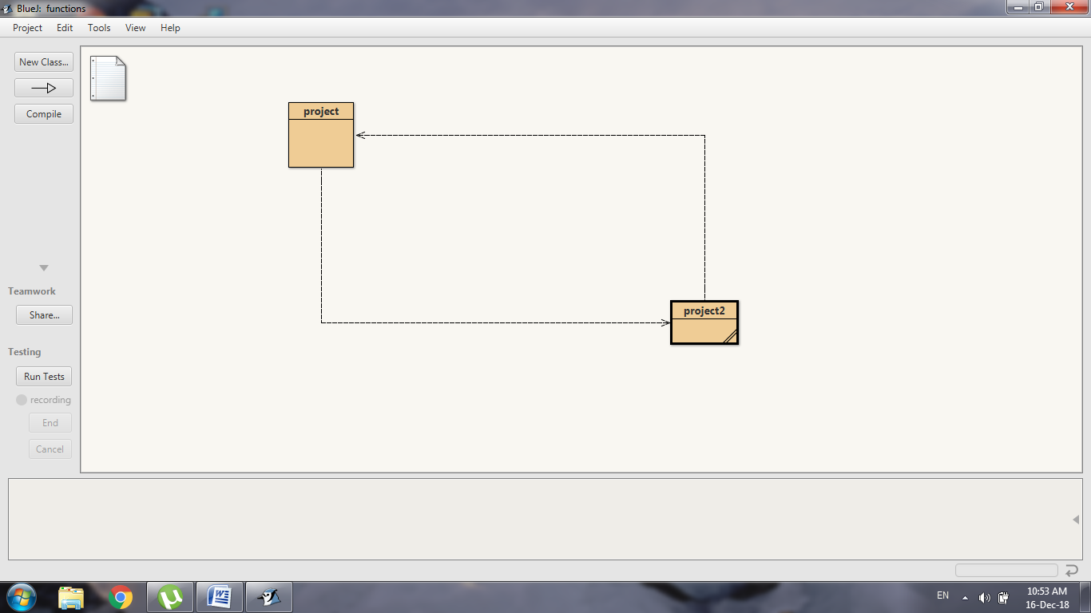

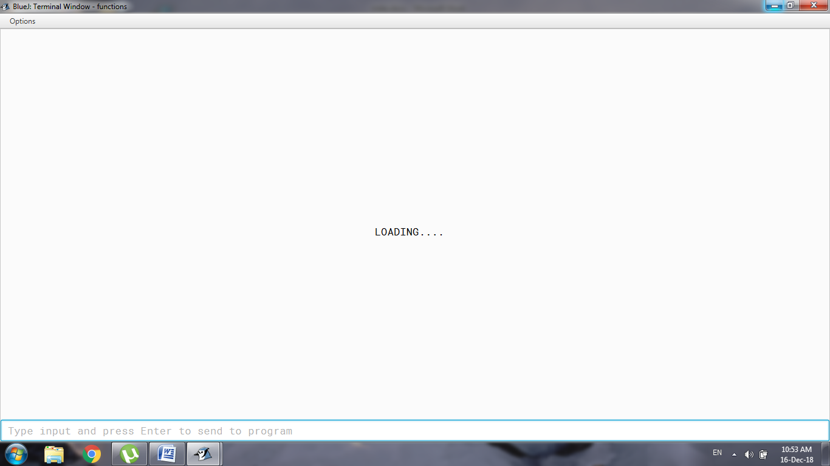

***Introduction:***

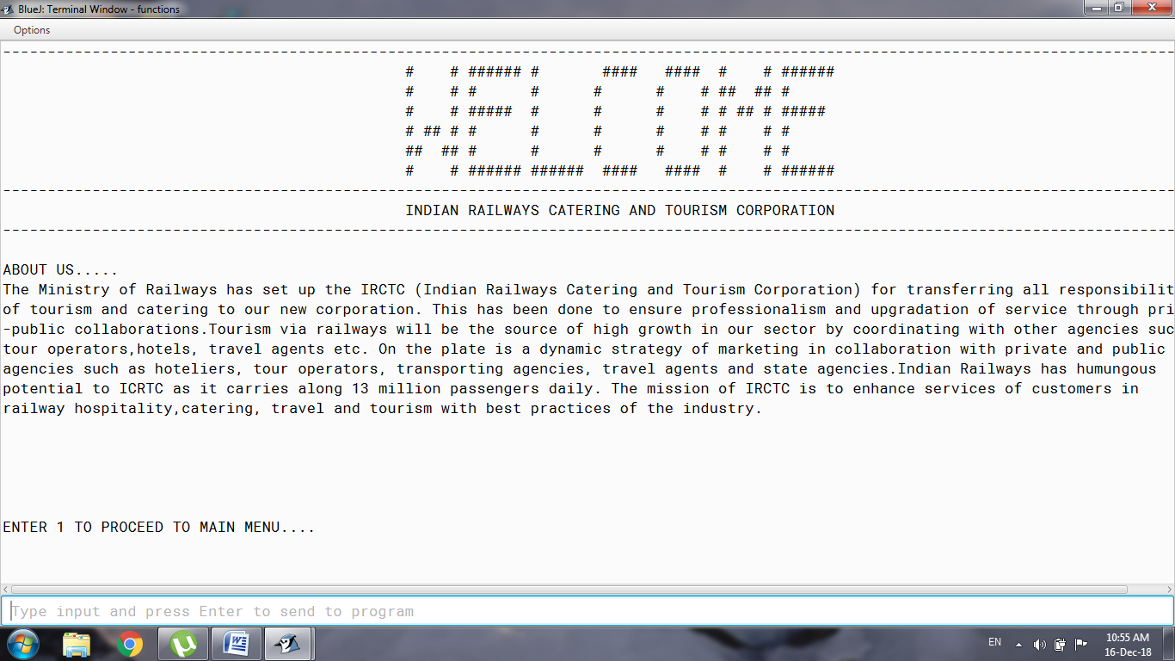

***If choice is made invalid***

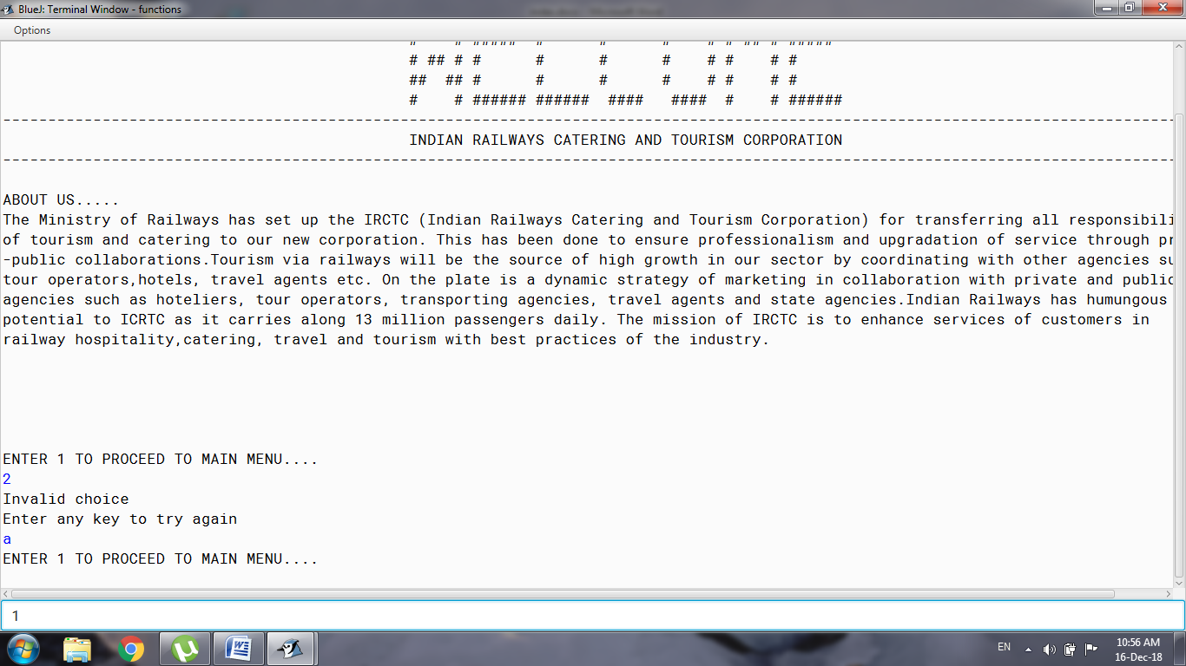

***MAIN MENU***

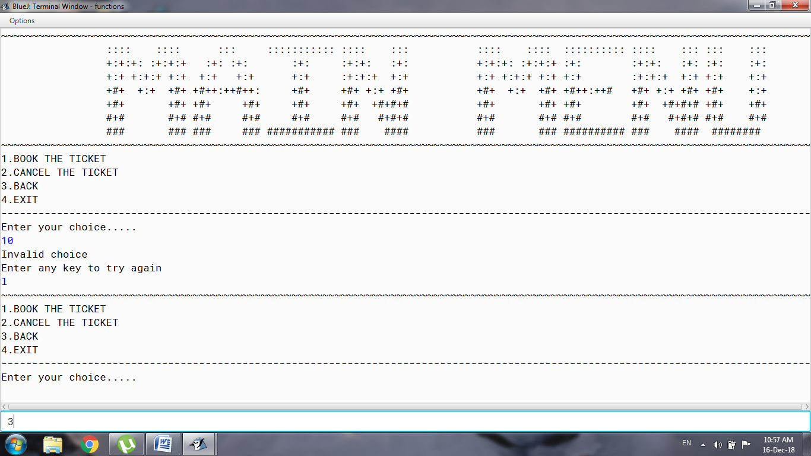

***If the choice made in the main menu is 3:***

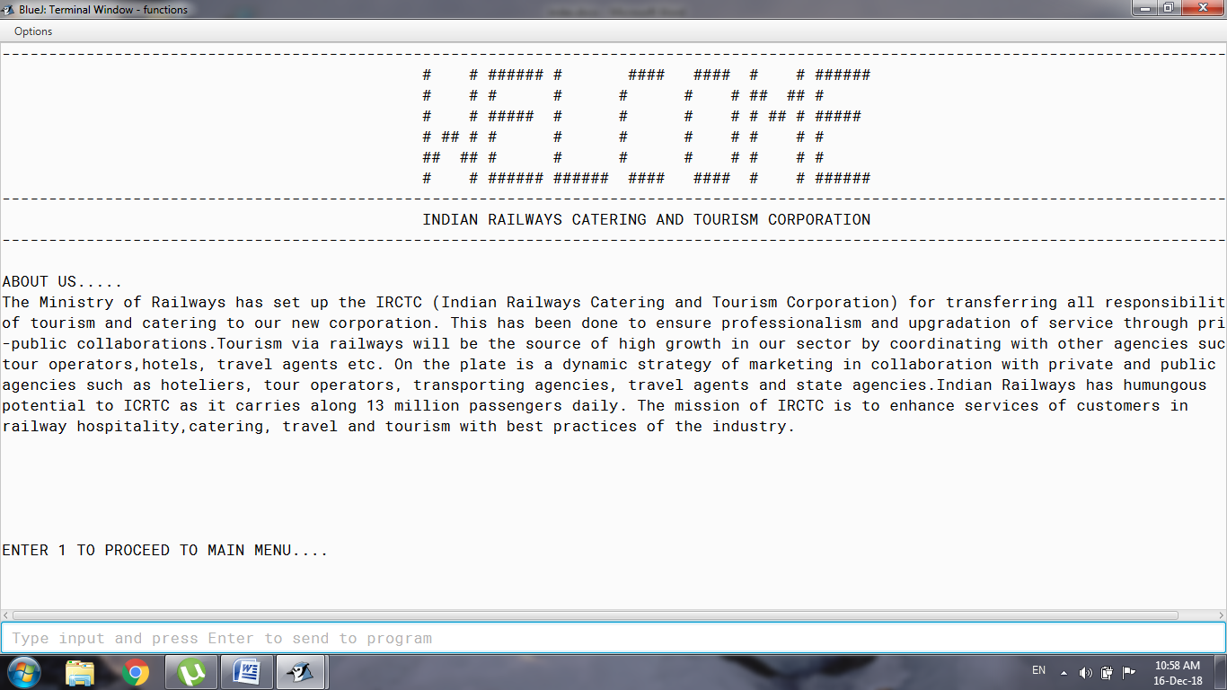

***If the choice made in the main menu is 1:***

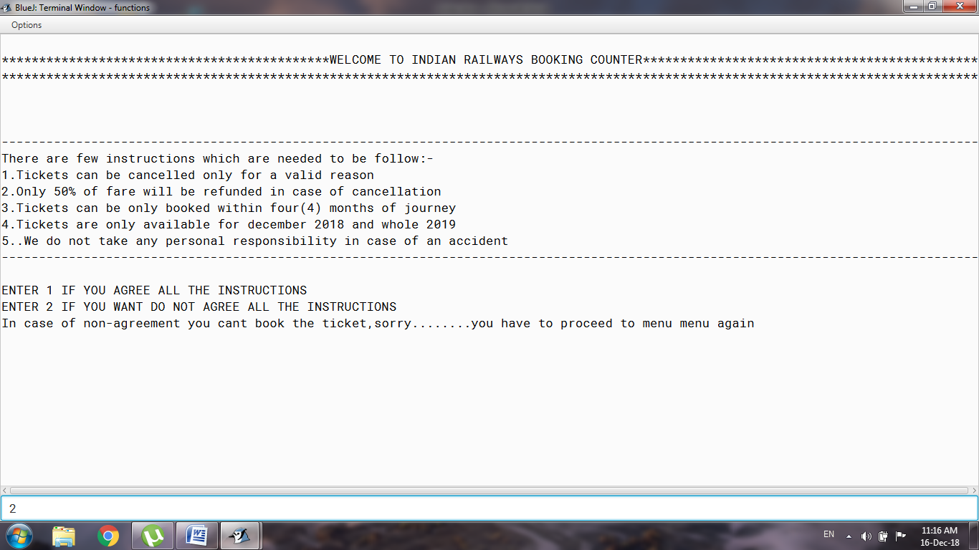

***If the Instructions are not accepted:***

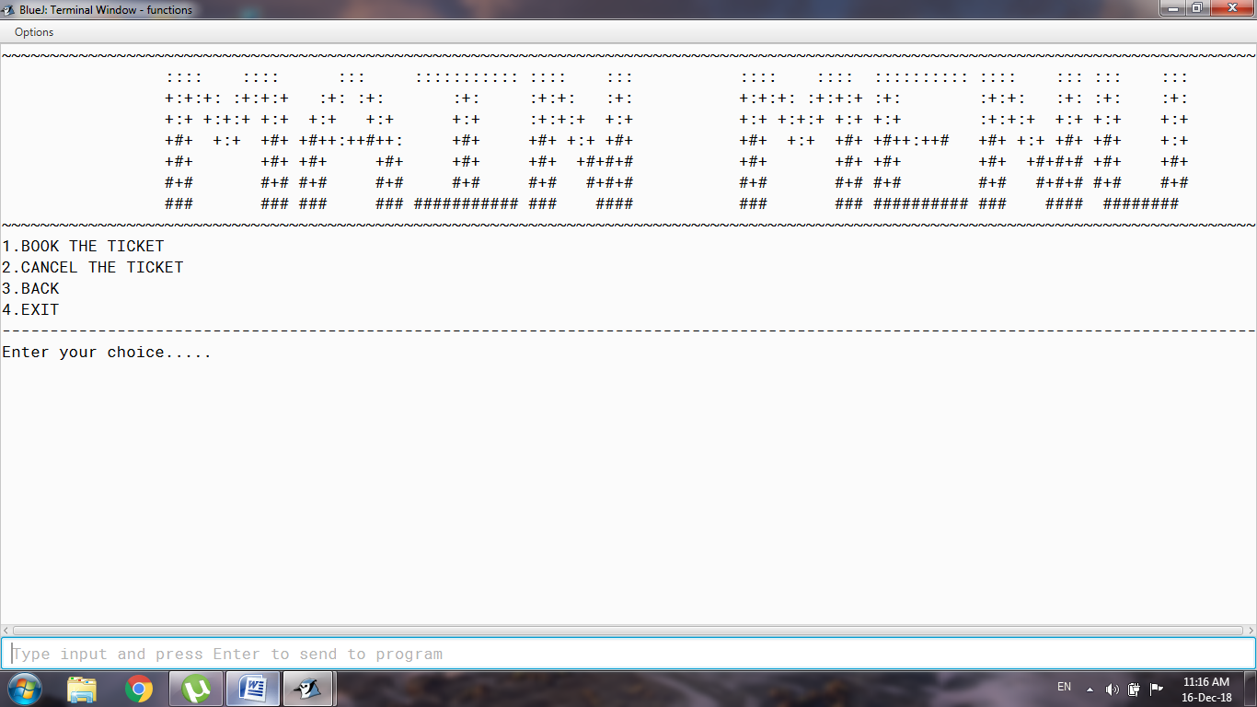

***If the Instructions are accepted:***

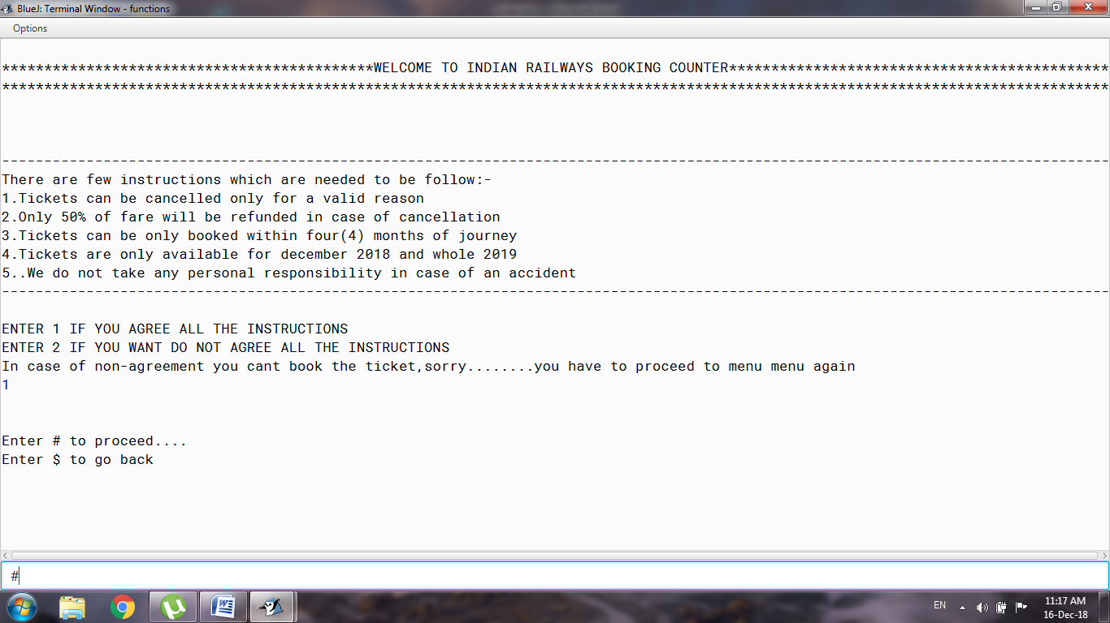

***If ‘#’ is Entered:***

***Taking of the date of journey***

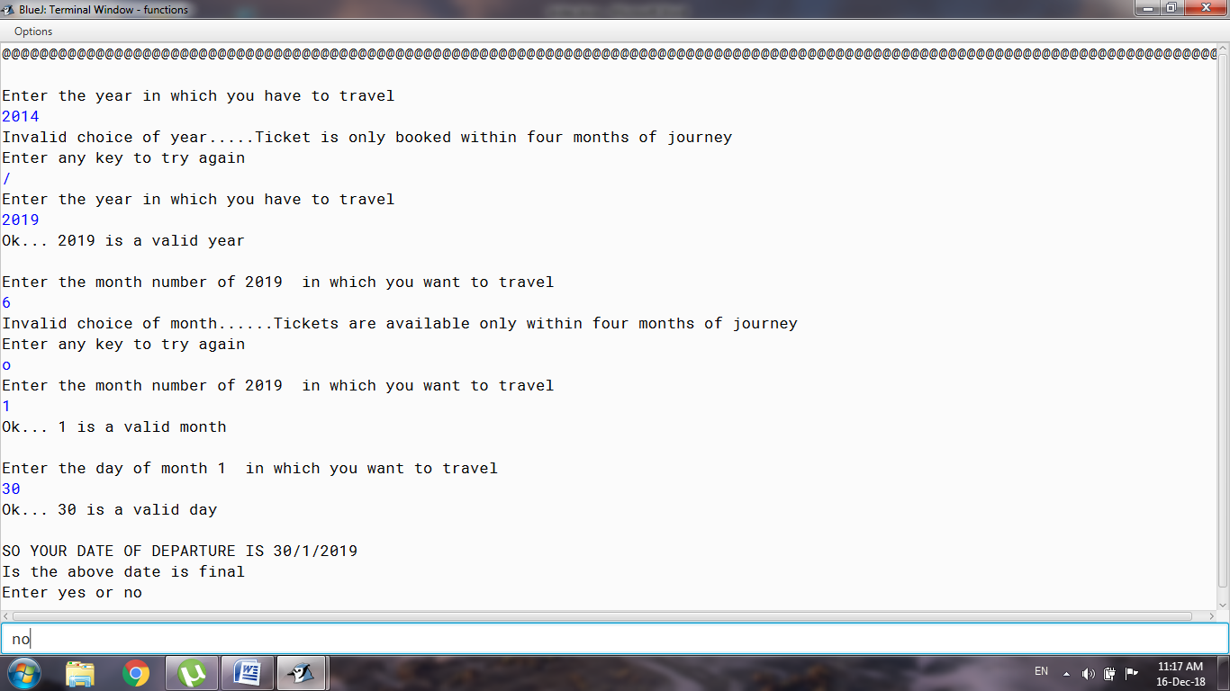

***If the date of journey is not final and ‘no’ is entered:***

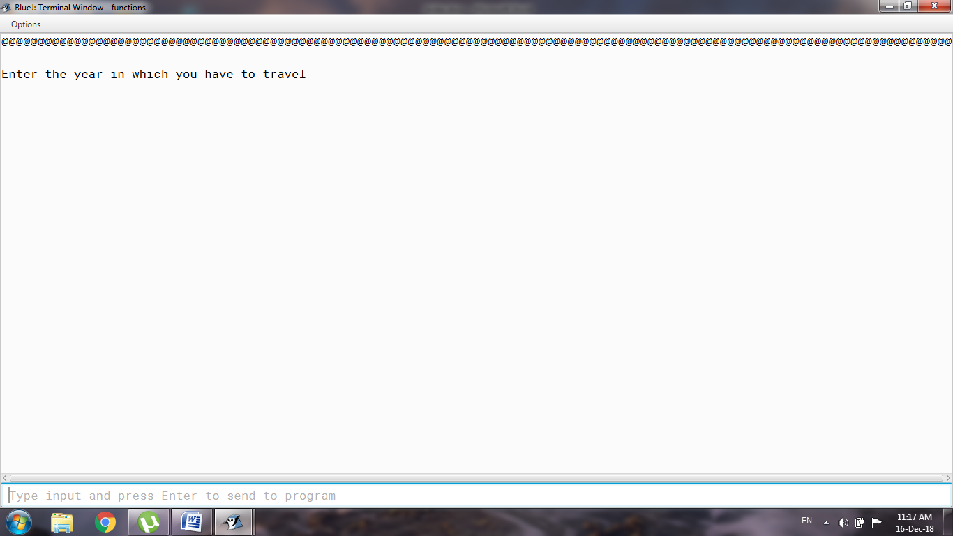

***If the date of journey is final and ‘yes ‘ is entered:***

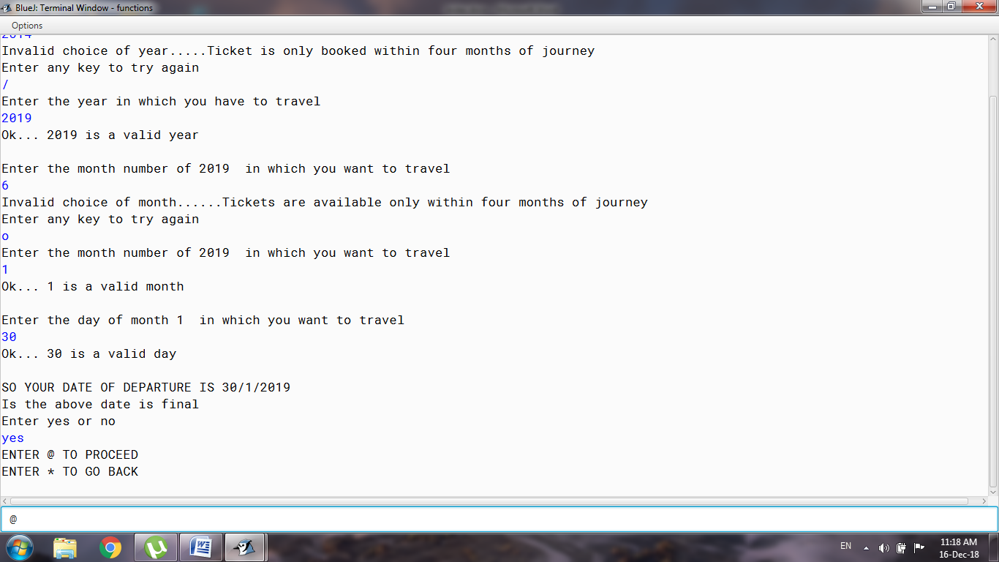

***If ‘@’ is entered:***

***Taking the starting point and destination of the journey***

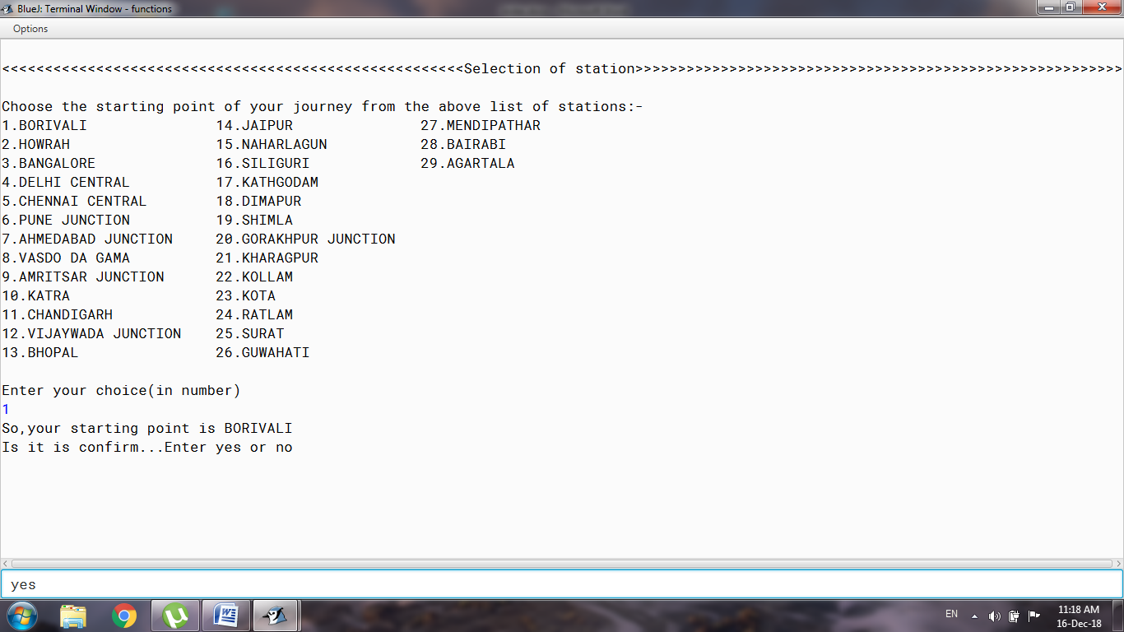

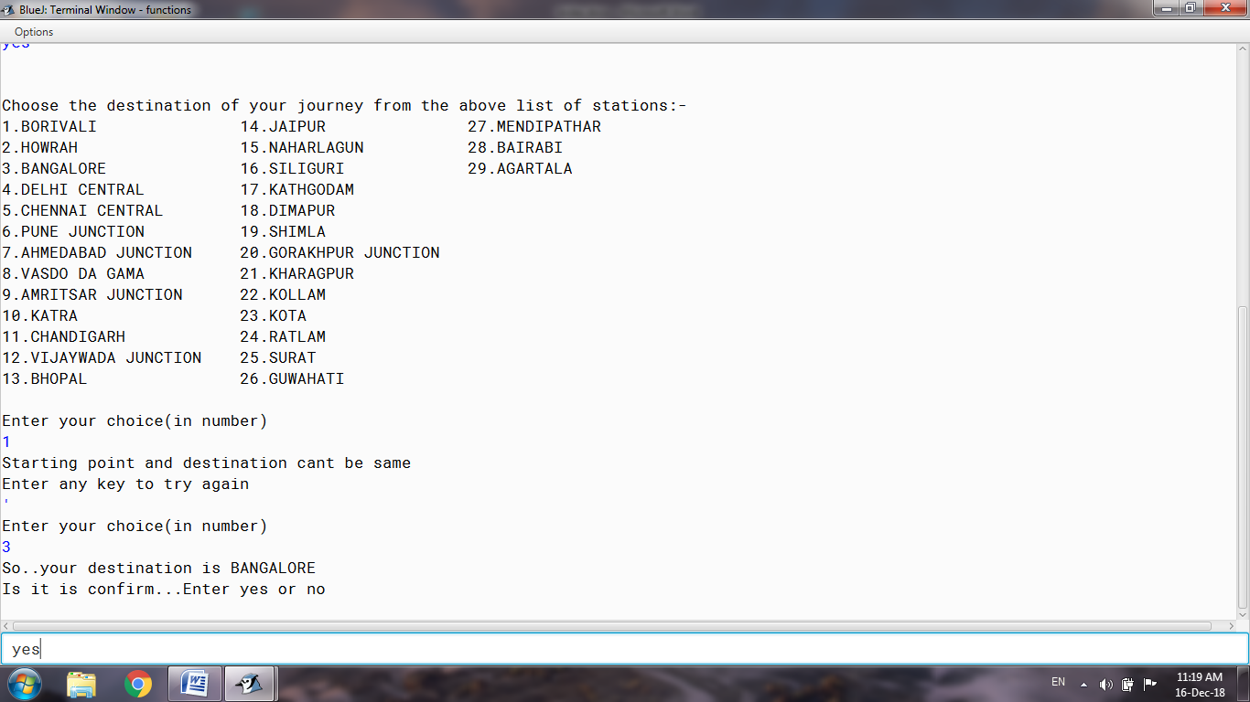

***If the starting point and Destination is confirmed:***

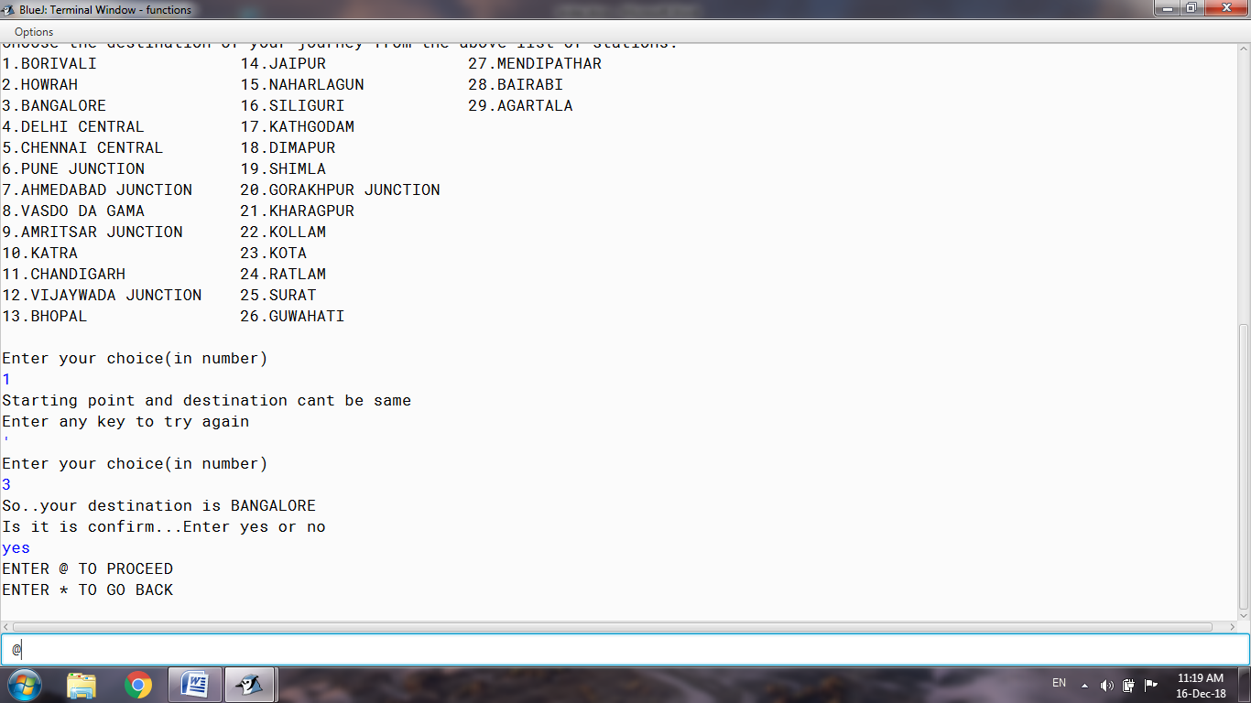

***If ‘@’ is Entered above:***

***Taking the Train name***

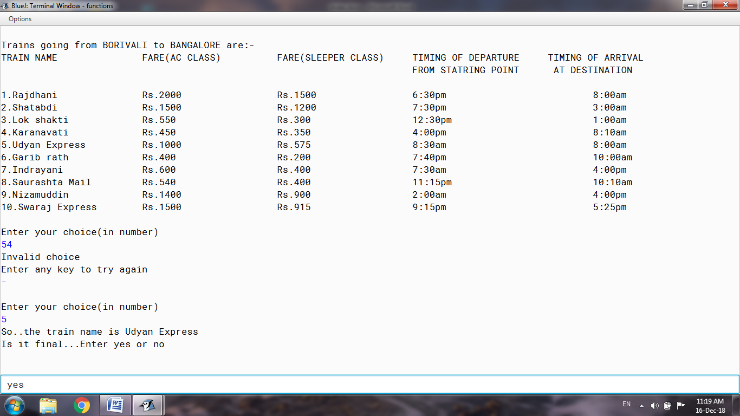

***Taking of the type of Coach:***

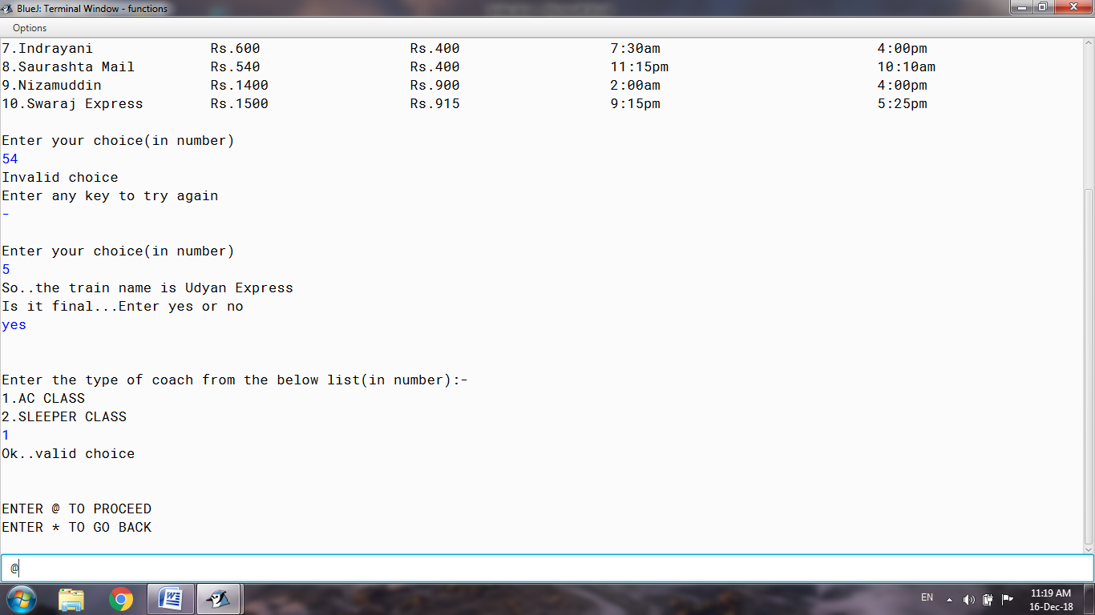

***If ‘@’ is Entered above:***

***Taking of the details of passenger***

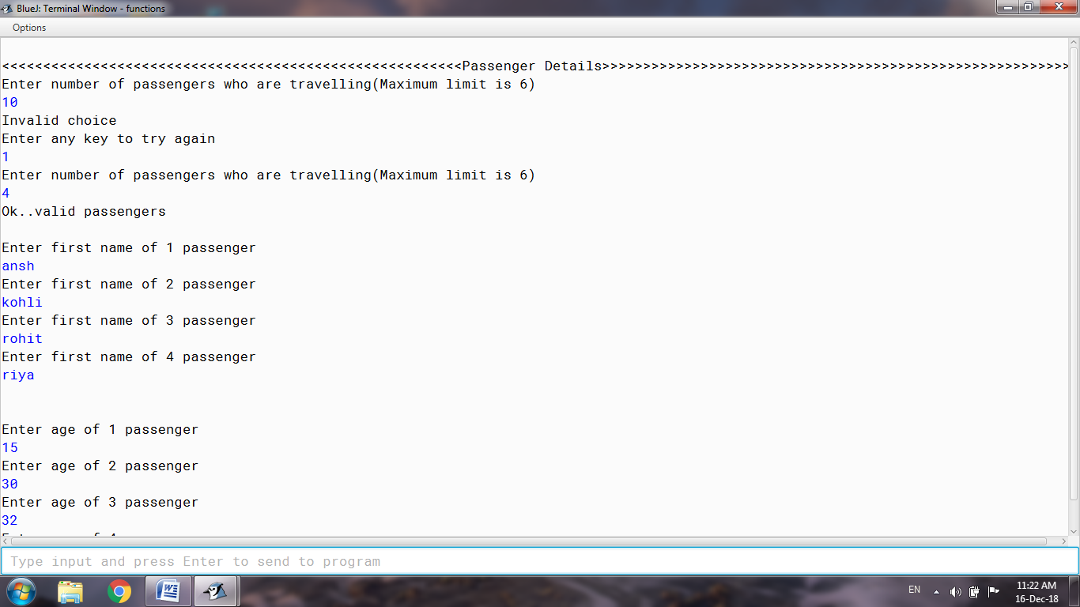

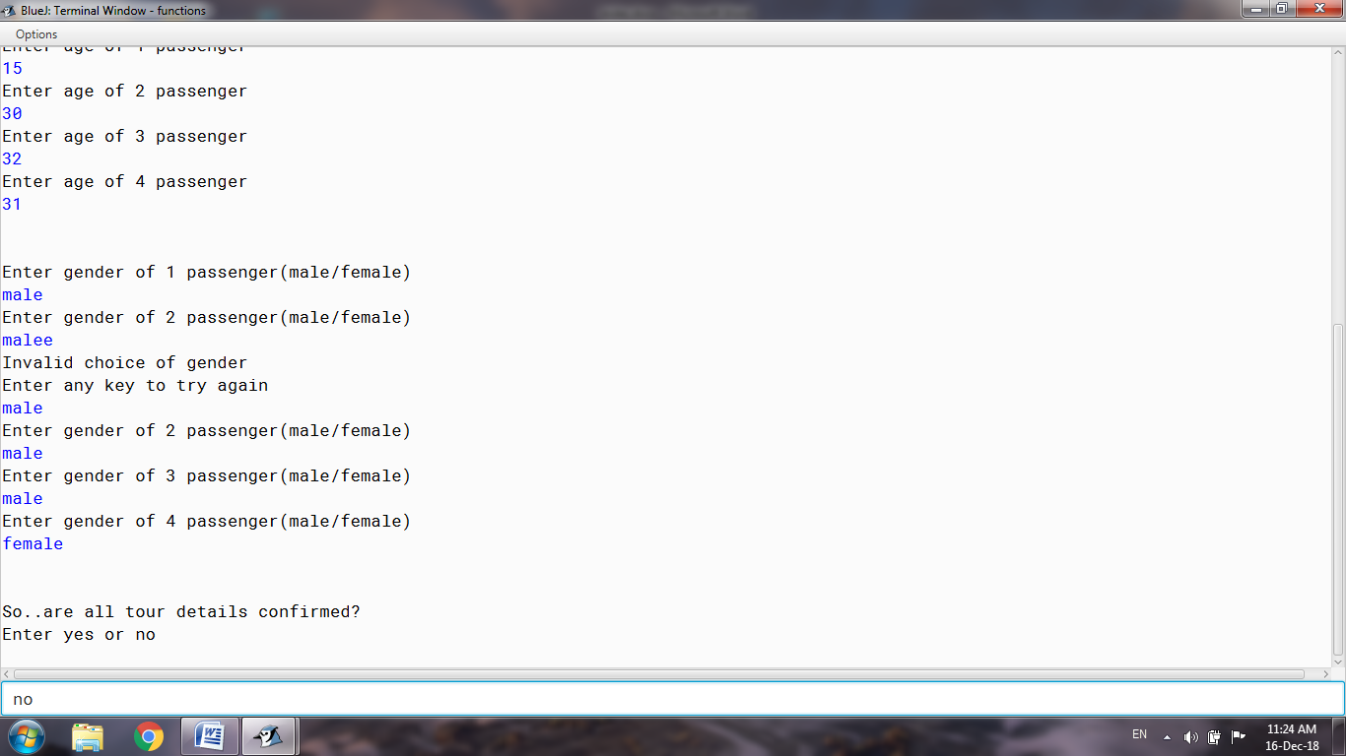

***If the Details are not confirmed and ‘no’ is Entered above:***

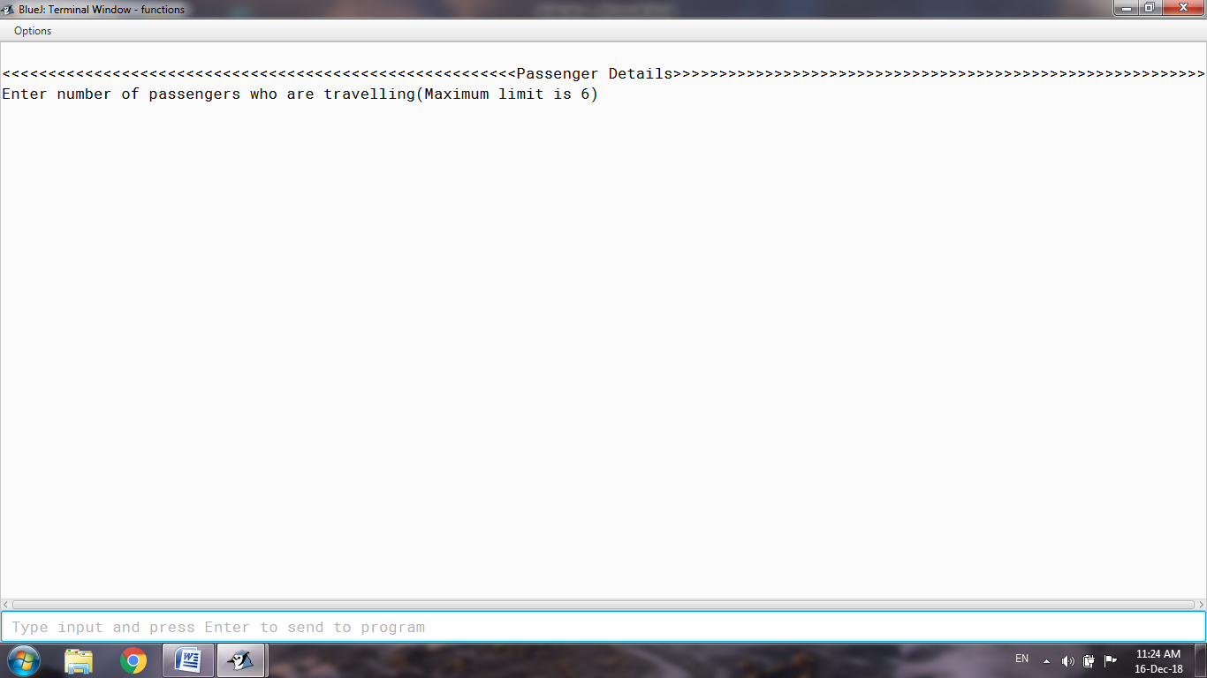

***If the Details are confirmed:***

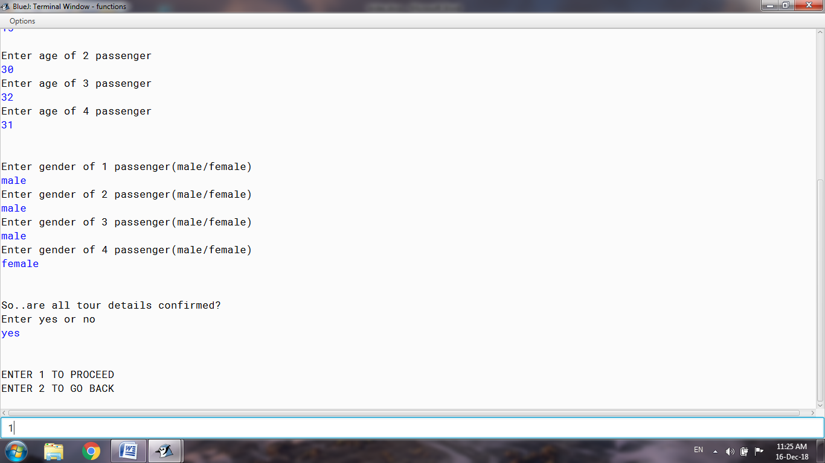

***If 1 is entered above:***

***Asking for food in the journey***

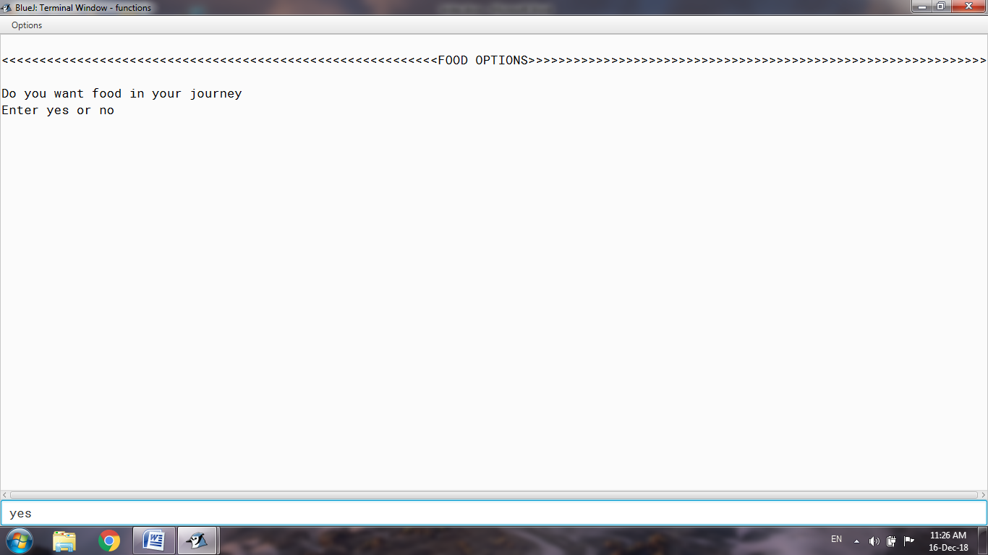

***If ‘yes’ is selected above:***

***Taking of the quantity and desired food item from the user***

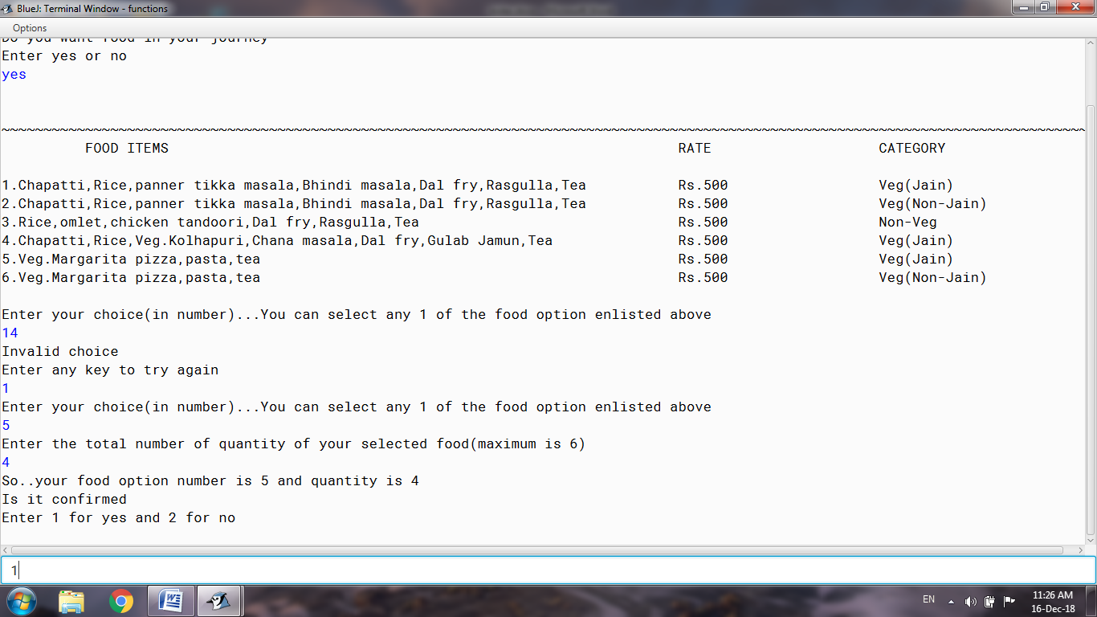

***If the food items are Confirmed:***

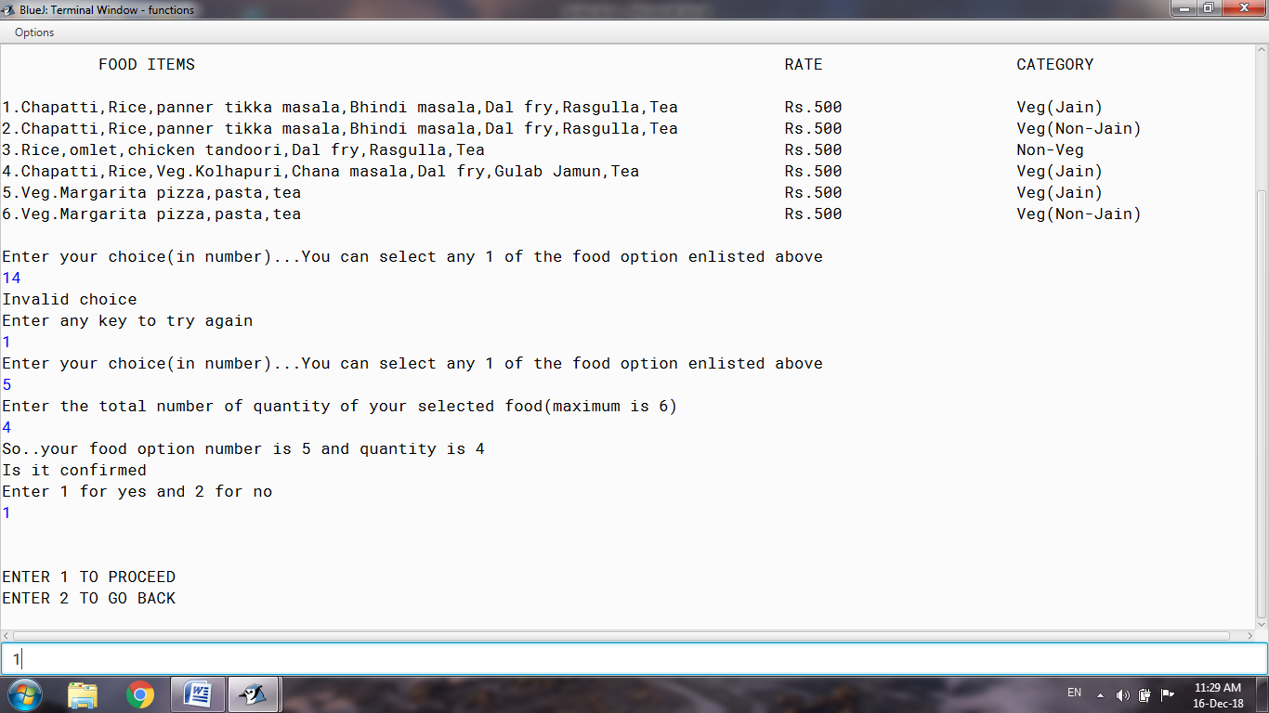

***If the User does not want food:***

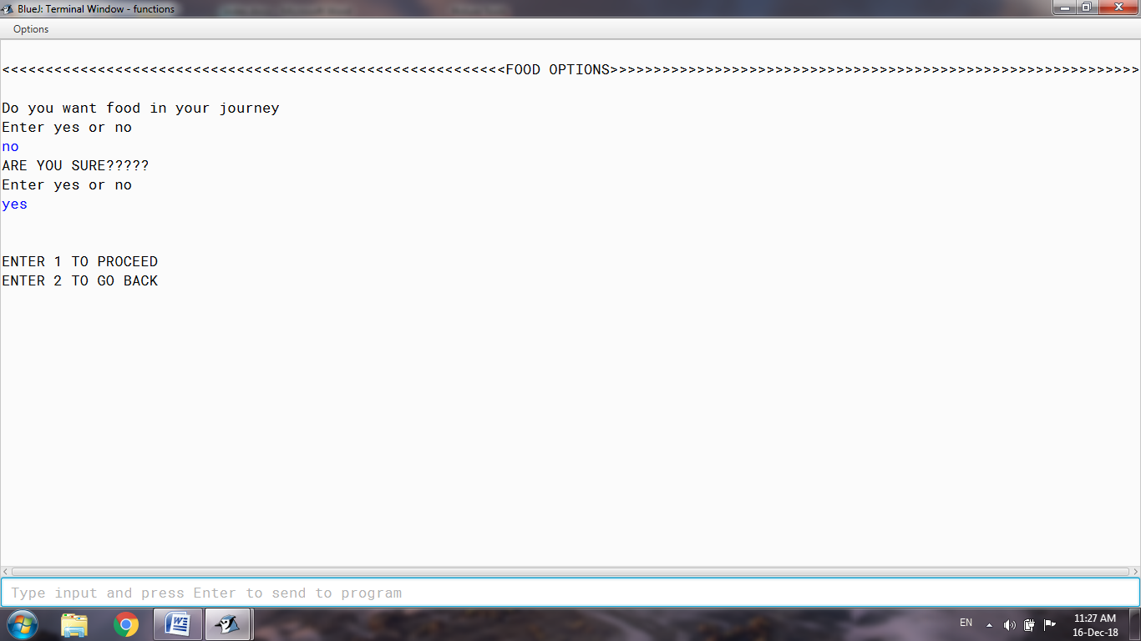

***If 1 is Entered above:***

***Asking to accept offer or not***

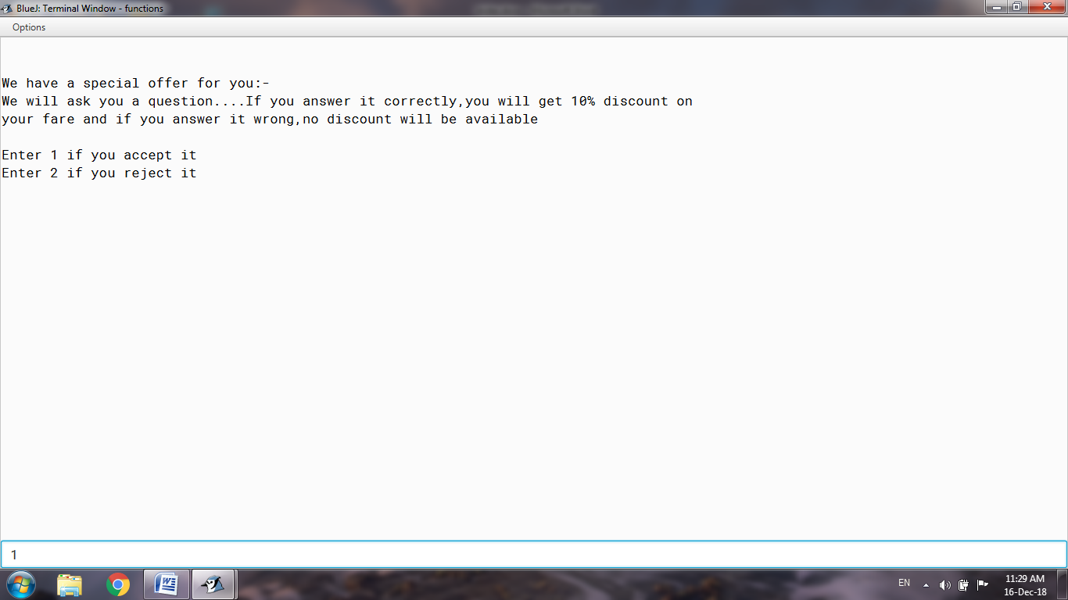

***If the offer is Accepted, the question is asked:***

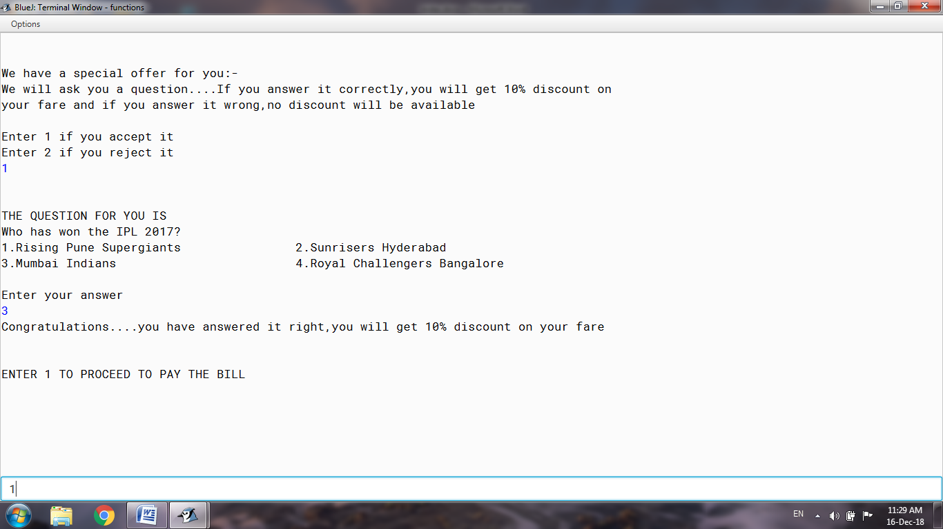

***If the offer is not accepted:***

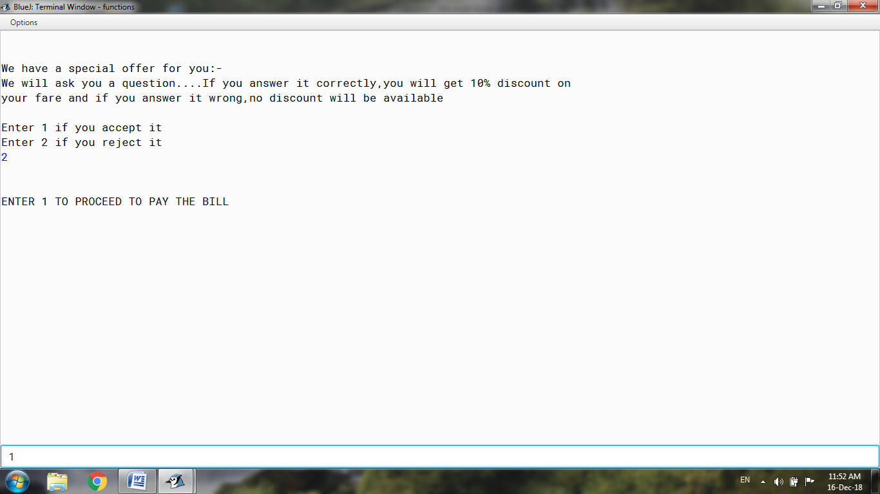

***THE BILL:***

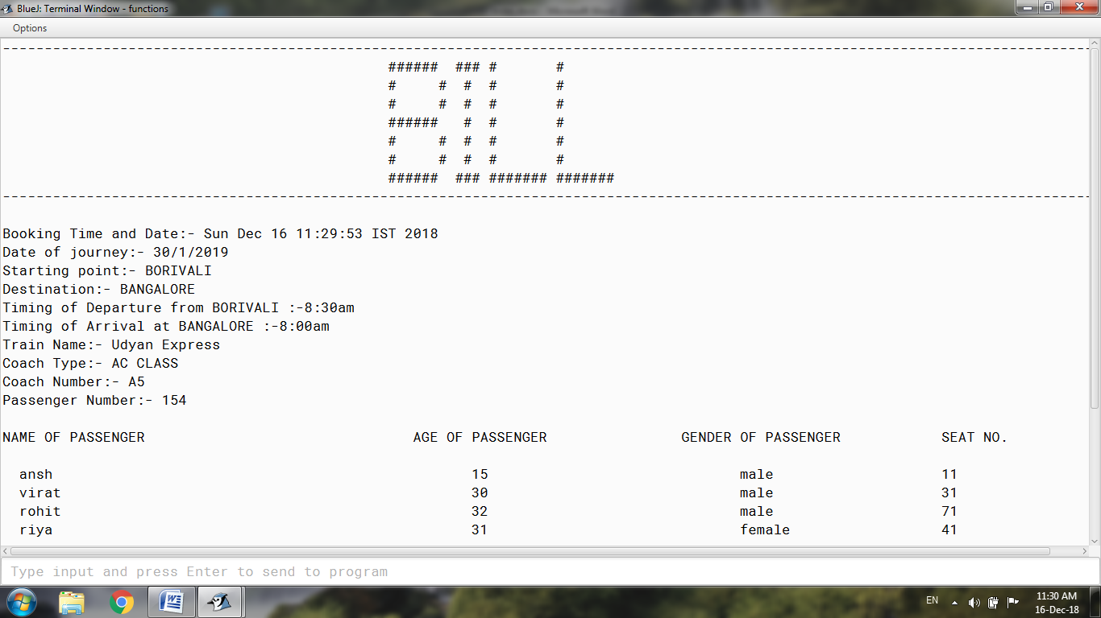

***Asking to pay the bill or not:***

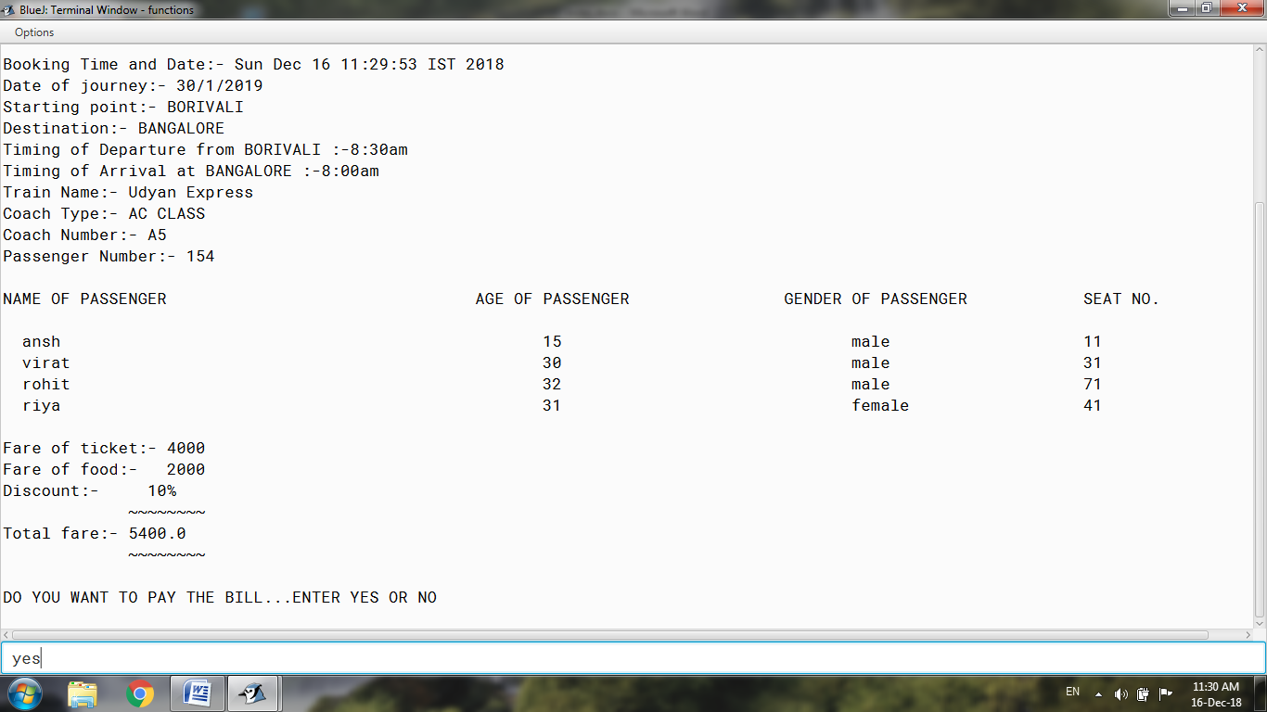

***Taking the mode of payment:***

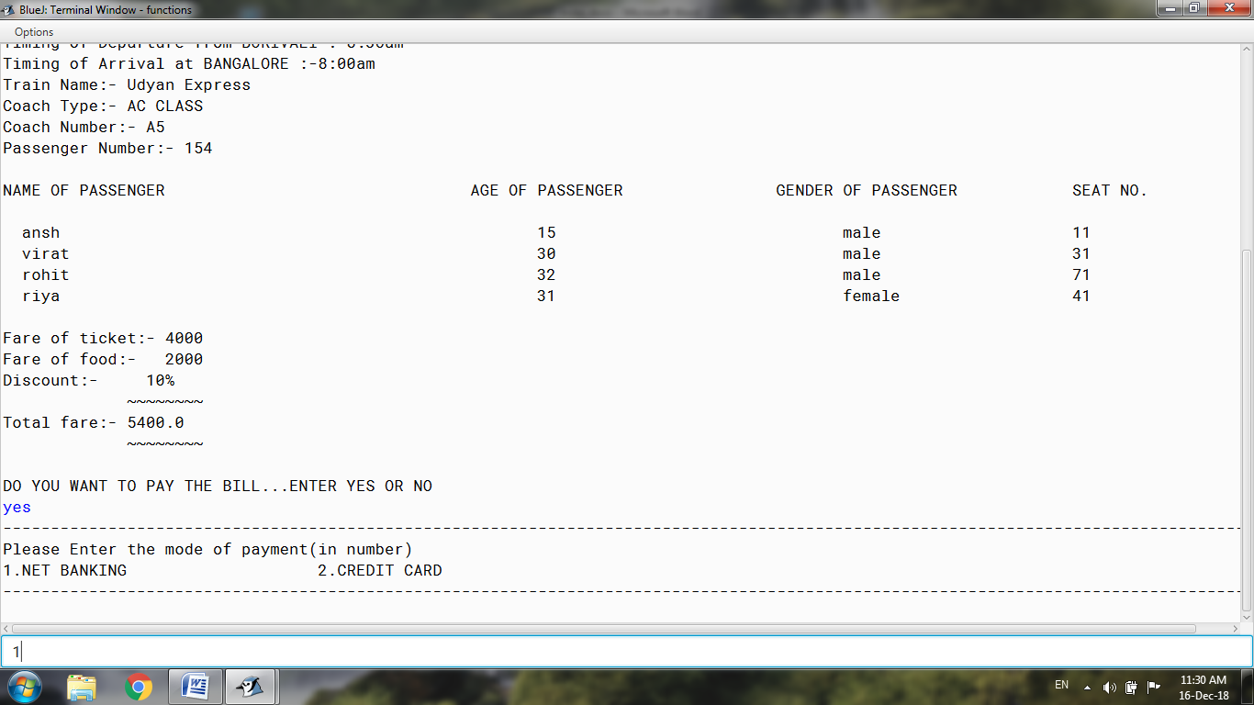

***If the mode of payment selected is Net banking:***

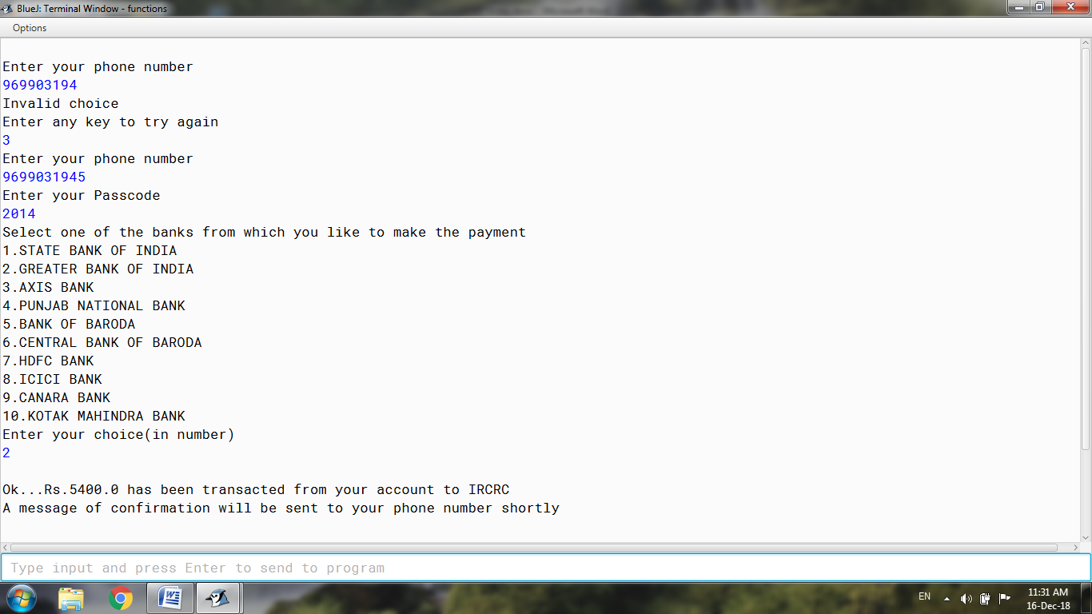

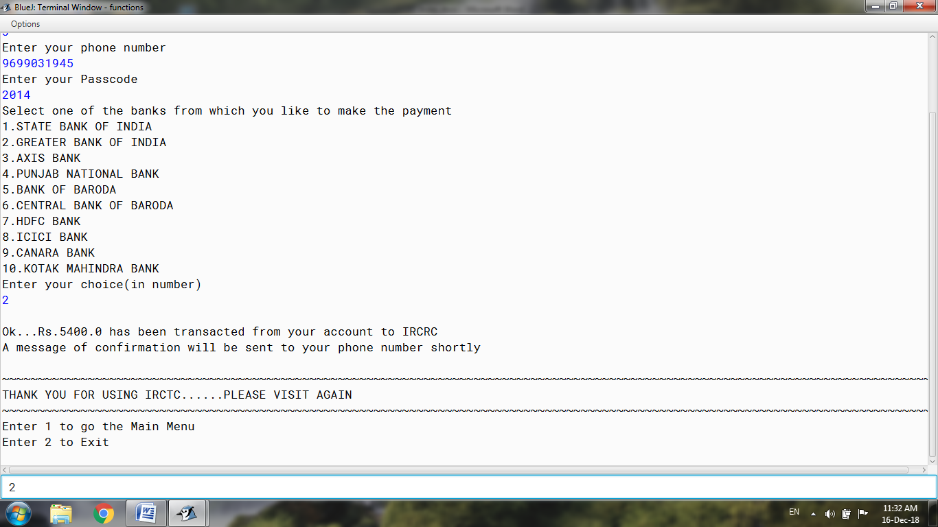

***If the mode of payment Selected is Credit card:***

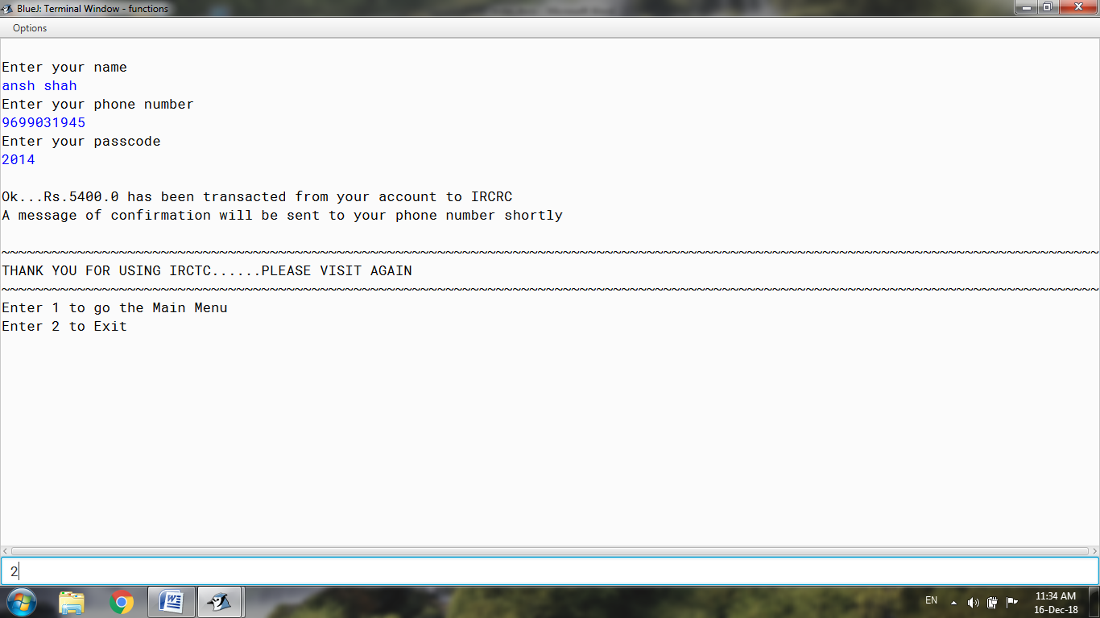

***If the option of going to the main menu is selected:***

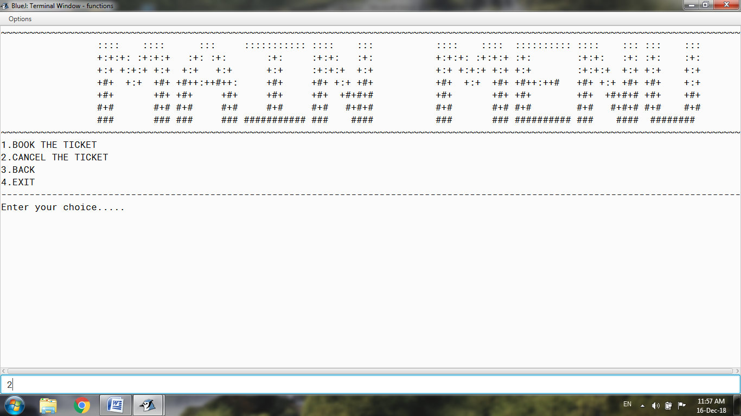

***If the user wants to cancel the ticket:***

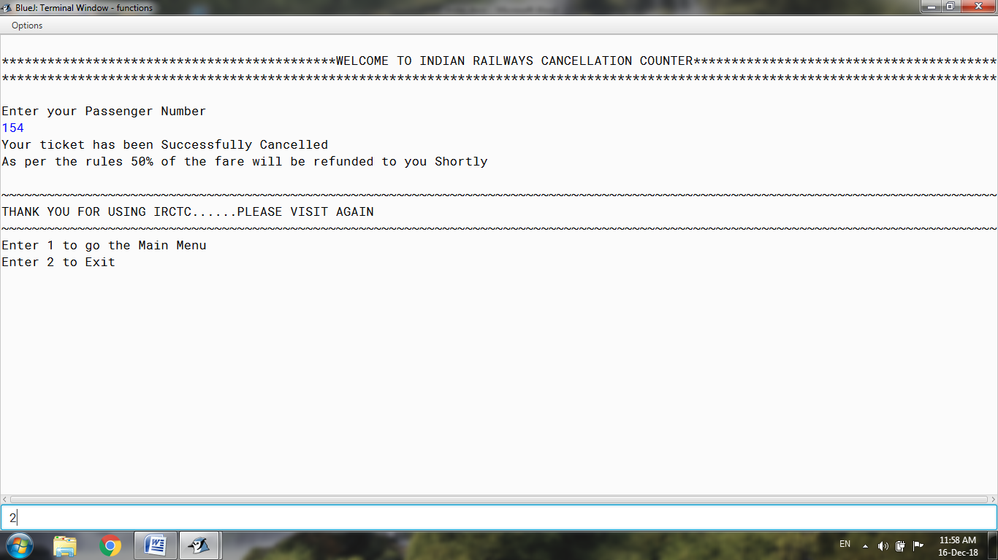

***If the Exit option is selected:***

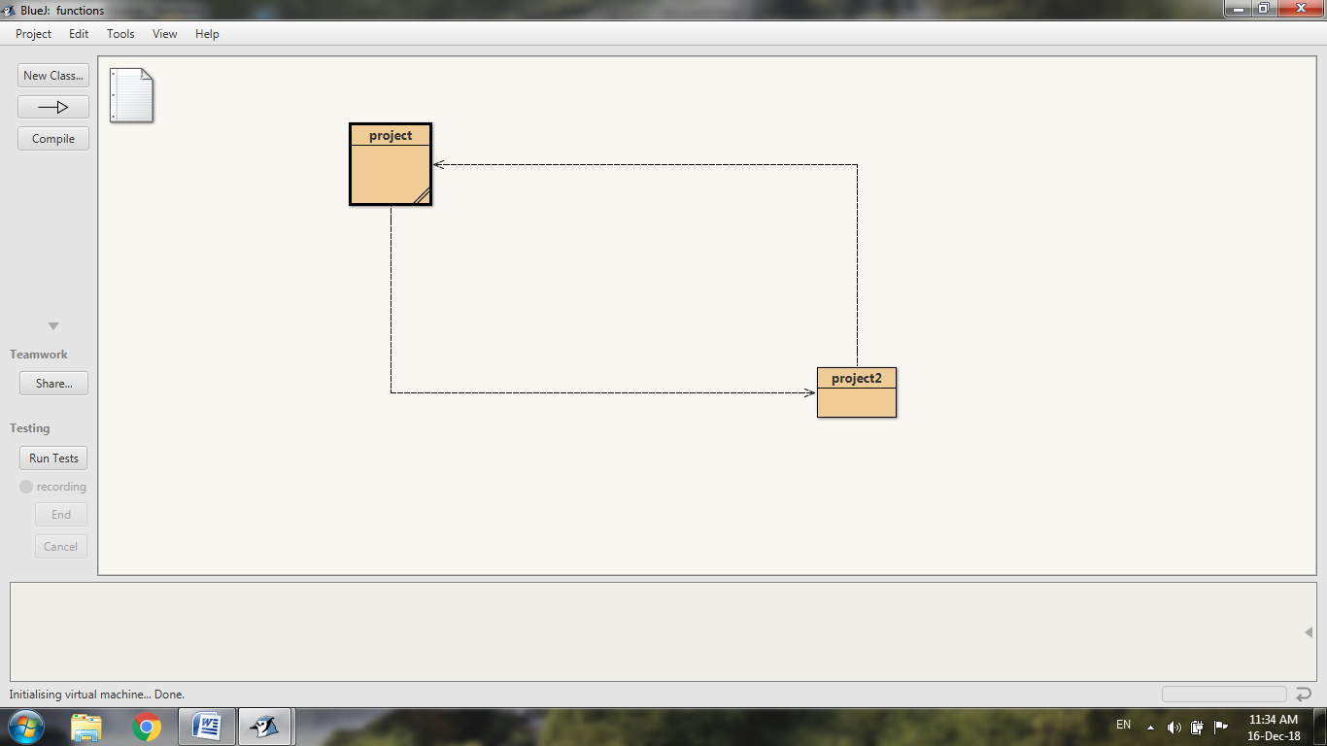

***VARIABLE TABLE***

***__________________________***

The variable list is as follows:-

|  |  |  |  |
| --- | --- | --- | --- |
| Sr no. | Variable | Data Type | Description |
| ***1.*** | ***Ch*** | ***Int*** | ***To take input of integer from the user as per his choice.*** |
| ***2.*** | ***P*** | ***Char*** | ***To take input of character from the user as per his choice, i.e. @,#,$,*.*** |
| ***3.*** | ***Y*** | ***Int*** | ***To store the year in which the user want to travel.*** |
| ***4.*** | ***M*** | ***Int*** | ***To store the month number in which the user want to travel.*** |
| ***5.*** | ***d2*** | ***Int*** | ***To store day if month in which the user want to travel.*** |
| ***6.*** | ***F*** | ***String*** | ***To take a String from the user like “yes” or “no”.*** |
| ***7.*** | ***I*** | ***Int*** | ***Used for loop control and program execution.*** |
| ***8.*** | ***J*** | ***Int*** | ***Used for loop control and program execution.*** |
| ***9.*** | ***y2*** | ***Int*** | ***To receive a integer and check for its validity.*** |
| ***10.*** | ***N*** | ***Char*** | ***To receive a character and check for its validity.*** |
| ***11.*** | ***A*** | ***Int*** | ***To receive a integer and check for its validity.*** |
| ***12.*** | ***B*** | ***Int*** | ***To receive a integer and check for its validity.*** |
| ***13.*** | ***Z*** | ***Int*** | ***To store the value of the current month.*** |
| ***14.*** | ***t*** | ***int*** | ***To receive a integer and check for its validity.*** |
| ***15.*** | ***G*** | ***Int*** | ***To receive a integer and check for its validity.*** |
| ***16.*** | ***d3*** | ***Int*** | ***To receive a integer and check for its validity.*** |
| ***17.*** | ***X*** | ***Int*** | ***To receive a integer and check for its validity.*** |
| ***18.*** | ***R*** | ***Int*** | ***To store the value of current date.*** |
| ***19.*** | ***Yn*** | ***String*** | ***To receive a String and check for its validity.*** |
| ***20.*** | ***O*** | ***Char*** | ***To receive a character and check for its validity such as @ and *.*** |
| ***21.*** | ***Tf*** | ***Double*** | ***To store the cost of fare and food.*** |
| ***22.*** | ***f1*** | ***Double*** | ***To store and display the final fare including the discount.*** |
| ***23.*** | ***Phone*** | ***String*** | ***To take the phone number from the user.*** |
| ***24.*** | ***h1*** | ***String*** | ***To take the passcode from the user.*** |
| ***25.*** | ***Dest*** | ***String*** | ***To store and display the destination entered by the user.*** |
| ***26.*** | ***Arr*** | ***String*** | ***To store and display the starting point entered by the user.*** |
| ***27.*** | ***Tr*** | ***Int*** | ***To take the choice of train in number from the user.*** |
| ***28.*** | ***H*** | ***String*** | ***To take a String from the user like “yes” or “no”.*** |
| ***29.*** | ***ch1*** | ***Int*** | ***To store the destination number entered by the user.*** |
| ***30.*** | ***Passengers*** | ***Int*** | ***To store the number of passengers travelling.*** |
| ***31.*** | ***x1*** | ***String*** | ***To store and display the coach type entered by the user.*** |
| ***32.*** | ***coach2[]*** | ***String*** | ***Array to store names of coach type.*** |
| ***33.*** | ***t2*** | ***String*** | ***To store and display the name of selected train.*** |
| ***34.*** | ***name[]*** | ***String*** | ***Array to take the name of the passengers travelling.*** |
| ***35.*** | ***Cnf*** | ***Int*** | ***To ensure the food taken.*** |
| ***36.*** | ***Coach*** | ***Int*** | ***To take the type of coach from the user.*** |
| ***37.*** | ***td*** | ***String*** | ***To display the timing of departure of train from the starting point.*** |
| ***38.*** | ***Ta*** | ***String*** | ***To display the timing of arrival of train at destination.*** |
| ***39.*** | ***gender[]*** | ***String*** | ***Array to take the gender of the passengers travelling.*** |
| ***40.*** | ***age2[]*** | ***Int*** | ***Array to take the age of the passengers travelling.*** |
| ***41.*** | ***Food*** | ***Int*** | ***To store the option of food.*** |
| ***42.*** | ***Offer*** | ***Int*** | ***To take the choice to select offer or not.*** |
| ***43.*** | ***Ans*** | ***Int*** | ***To ensure that answer is answered right.*** |
| ***44.*** | ***Foodquantity*** | ***Int*** | ***To take the quantity of food selected.*** |
| ***45.*** | ***Fare*** | ***Int*** | ***To calculate the fare.*** |
| ***46.*** | ***station[]*** | ***String*** | ***Array to store station names.*** |
| ***47.*** | ***train[]*** | ***String*** | ***Array to store train names.*** |
| ***48.*** | ***cost[]*** | ***Int*** | ***Array to store cost of AC trains.*** |
| ***49.*** | ***cost2[]*** | ***Int*** | ***Array to store cost of sleeper trains.*** |
| ***50.*** | ***time1[]*** | ***String*** | ***Array to store timing of departure of trains.*** |
| ***51.*** | ***time2[]*** | ***String*** | ***Array to store timing of arrival of trains.*** |
| ***52.*** | ***sc*** | ***Scanner object*** | ***To take the input from the user.*** |
| ***53.*** | ***sc1*** | ***Scanner object*** | ***To take the input from the user.*** |

***CONCLUSION***

***__________________________***

This project has been a great tutor as far as practical aspects of programming are concerned. I planned the program with my classmates and then discussed it with my computer teacher. After drafting the source code, I punched it in the computer followed by debugging and testing it, at home. Subsequently, I was able to get an error free code to put in my project.

This has not only drilled me on the Subject but also taught me things like teamwork, time management, research work and presentation skills. These are the lessons for my life, with will always stay with and help me in my career.

***ACKNOWLEDGEMENT***

***__________________________***

This project would not have been possible without the guidance and the help of several individuals who in one way or another contributed and extended their valuable assistance in the preparation and completion of this study.

First and foremost, I express utmost gratitude to our Computer teacher- ***Mr. Harshad chaudhari*** whose inputs and encouragement has been my inspiration as I hurdle over the obstacles in the completion of this project work.

I am specially Thankful to my Principal -***Miss Uma mukerji*** for providing me with his opportunity.

I thank all the members of the family who always had a kind concern and consideration regarding all my project and academic requirements. Last but not the least, I thank my classmates for all the cooperation and resources they extended to me.

***BIBLIOGRAPHY***

***__________________________***

All the necessary information is taken from various books which are mentioned as follows:-

1. Understanding Computer Application:

ARYA PUBLISHERS.

1. Computer Application by Gautam Roy.

And also and from Internet. The websites are:-

1. www.patorjk.com
2. www.scribd.com